



AlGorıthmıc tradıng bot

GRADUATION SENIOR PROJECT INTERMEDIATE REPORT



**by**

İrem sultan bulut

20150807016

**SupervIsed by**

Asst. Prof. Dr. Mustafa Berkay Yılmaz

# CONTENTS

CONTENTS 1

1. INTRODUCTION 3

2.EXPLANATİON OF THE IMPLEMENTATION AND THE METHODS 3

2.1. Main Parts 3

2.2.Interface Parts 11

2.3.Connectors Parts 19

3. Mockup and Documentation For The Interface 24

4. Test and Experiments 26

1

1. **INTRODUCTION**

The trading robot is an application that can run in accordance with set parameters. They consist of instructions and certain algorithms, which are configured to recognize trends and automate trading in this work. This project is a program that runs in the background for the platform you trade. On trading platforms such as Binance and Bitmex, you determine your trades and strategies on this program. You connect this bot to your Binance and Bitmex account with your API and Secret Keys. According to the strategy you set, the bot automatically trades on your accounts. There are 2 different strategies you can choose in this project. These are: Technical and Breakout strategies. After choosing one of these strategies, you determine what percentage of the amount you have in hand you want to enter. You then set a peak to make a profitable sell trade and a stop loss point to exit without further loss. Of course, you also determine the type of coin on the platform you want to trade. Finally, after determining the time you want it to continue trading, you can run your bot. Your bot will analyze the situation and determine its short or long transactions. It continues the trade by making trading transactions within the settings range you specified. When the time you set for trading is over, the bot stops working. If you see enough, you can stop your trading bot. You can trade by adding more than one strategy. You can see the ask and bid prices on this platform by subscribing to the coins you want to see.

The difference of this bot from existing platforms is that you can do more than one transaction instantly. On normal platforms, you set a stop loss to exit with little loss, but the price you set may have changed until you entered this trade. However, the strategies you set on this bot remain registered. When you see a suitable position, you can start trading transactions without missing the affordable price by running the bot instantly. You can follow that you are in a negative or positive position as a result of the transactions made in the PNL section.

Cryptocurrency is very popular nowadays. Trade Bots are just the right way to make transactions faster and gain more profitability.

1. **EXPLANATİON OF THE IMPLEMENTATİON AND THE METHODS**
   1. **Main Parts**

* **main.py**

This section checks the person's Binance and Bitmex accounts, and if they are correct, these accounts are logged. If you have the API and Secret Key of an account, you do not need anything else to trade with this account. The entry of other pages starts here. If the account is not correct, you cannot perform any action in the window that opens If your login is successful, you will receive a successful login message with the time.

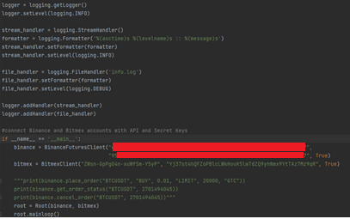

* **models.py**

We define separate wallets for Bitmex and Binance. When buying the wallet, we enter the variable values ​​of the required data. The values ​​here are chosen the same as the variables in the Binance documentation section.

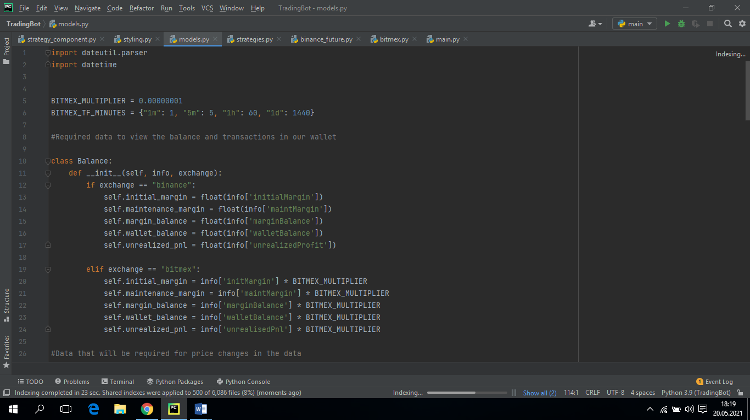 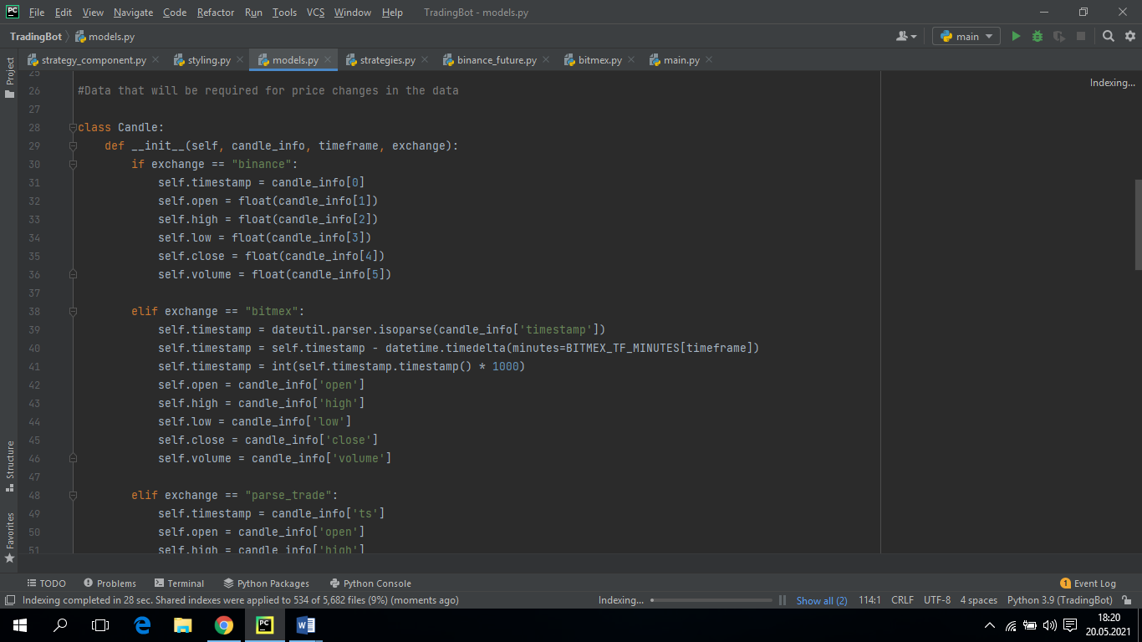

Conract part is the part where we see coin types that can be used in binance and bitmex accounts. Every coin has symbol, base symbol, quote symbol. The base symbol shows the name of the coin we see. The quote symbol is the name of the price we want the coin to see. For example BTC / USDT, BTC is base symbol and USDT is quote symbol.

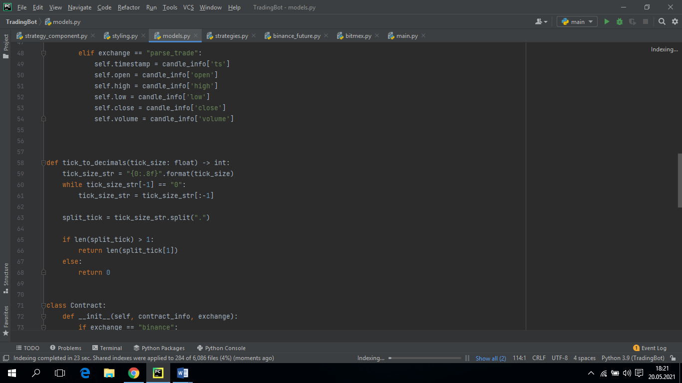 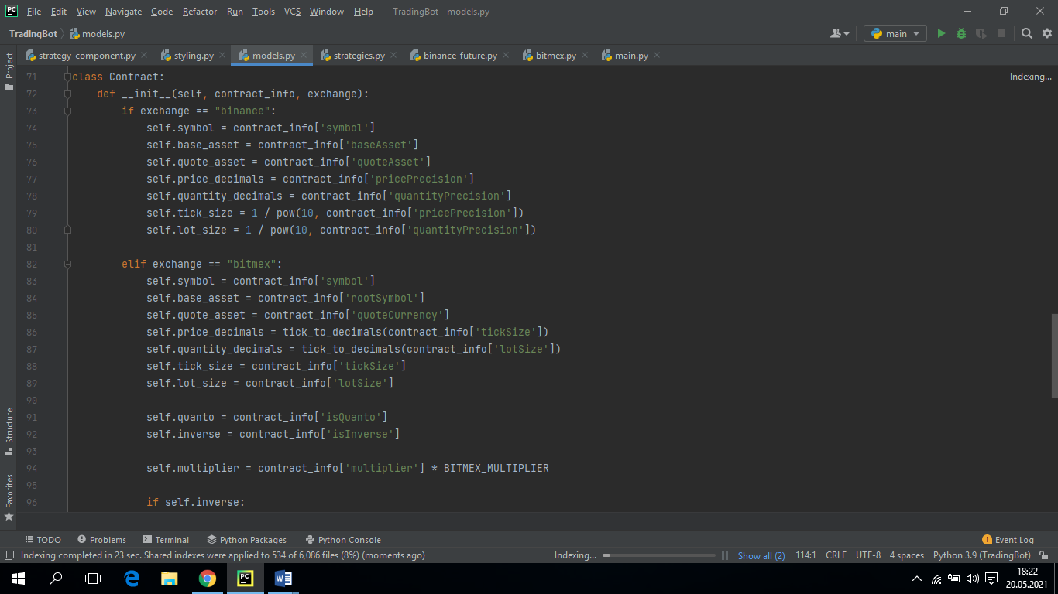 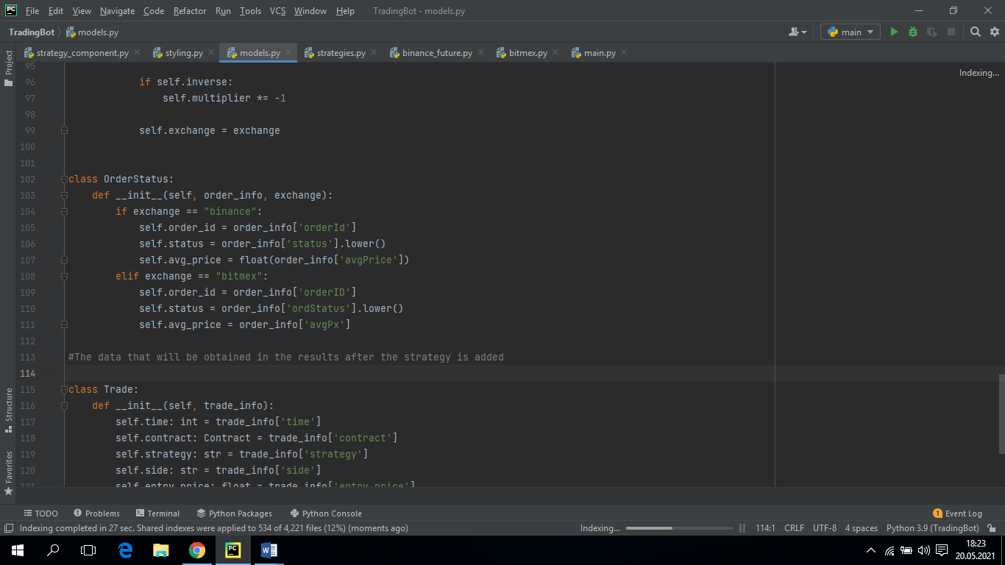

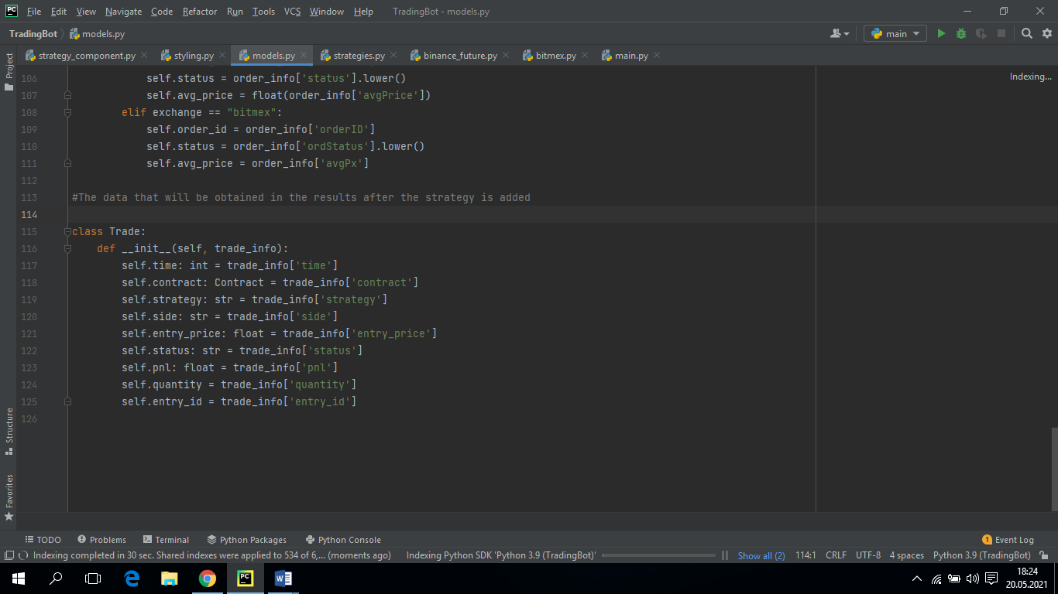

In the Trade section, it is the place where the data of our trade after processing is seen. Time is the time the transaction was made. Contract coin is the name and platform of the transaction. PNL is the amount of money you lost or gained. Status indicates if he is currently in position.

* **strategies.py**

Strategy is the most important part of the program. There are two different types of strategies in this section. Breakout and Technical. After choosing one of these strategies, you determine what percentage of the amount you have in hand you want to enter. You then set a peak to make a profitable sell trade and a stop loss point to exit without further loss. Of course, you also determine the type of coin on the platform you want to trade.

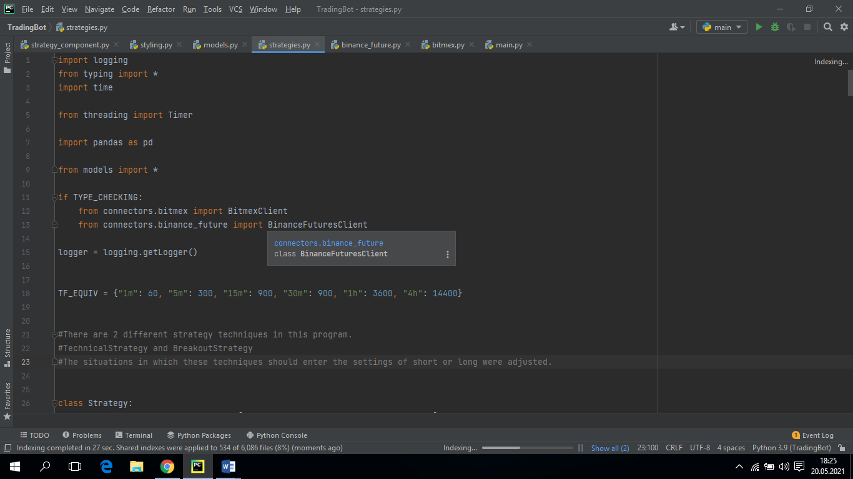

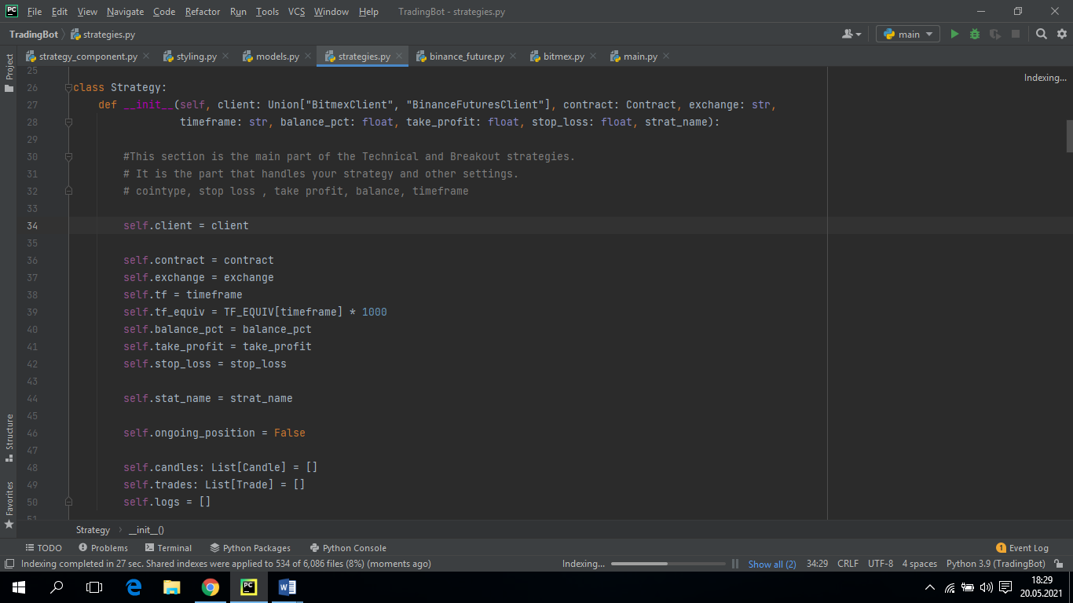 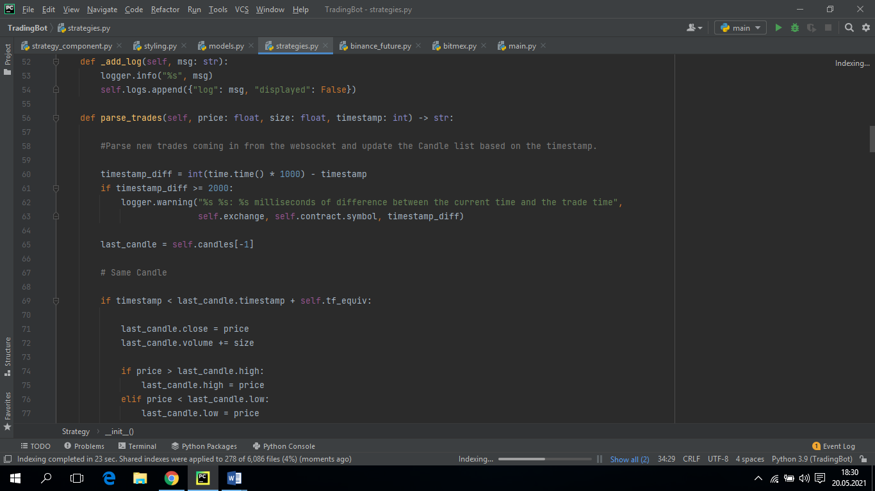

A trading chart is made up of candles. If the value of the coin has increased, these candles form a green and a candle that is between its previous value and its current value. If the value of the coin has dropped, it creates a red candle between the previous value and the current value. These candles have a specific time. After this time has passed, a candle is formed on the graphic. The direction of these candles is very important in a strategy.

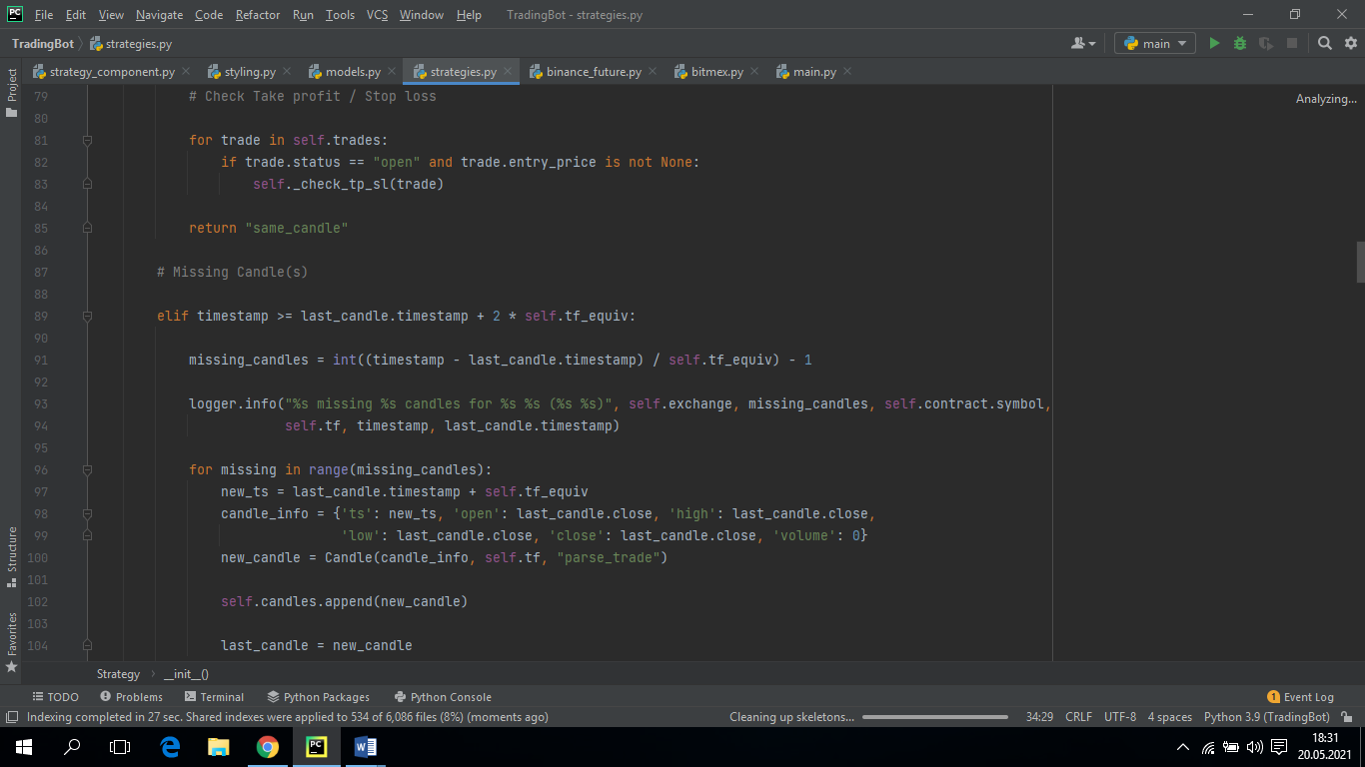 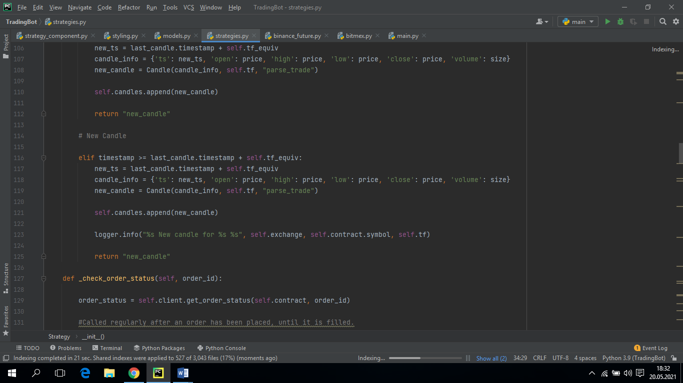 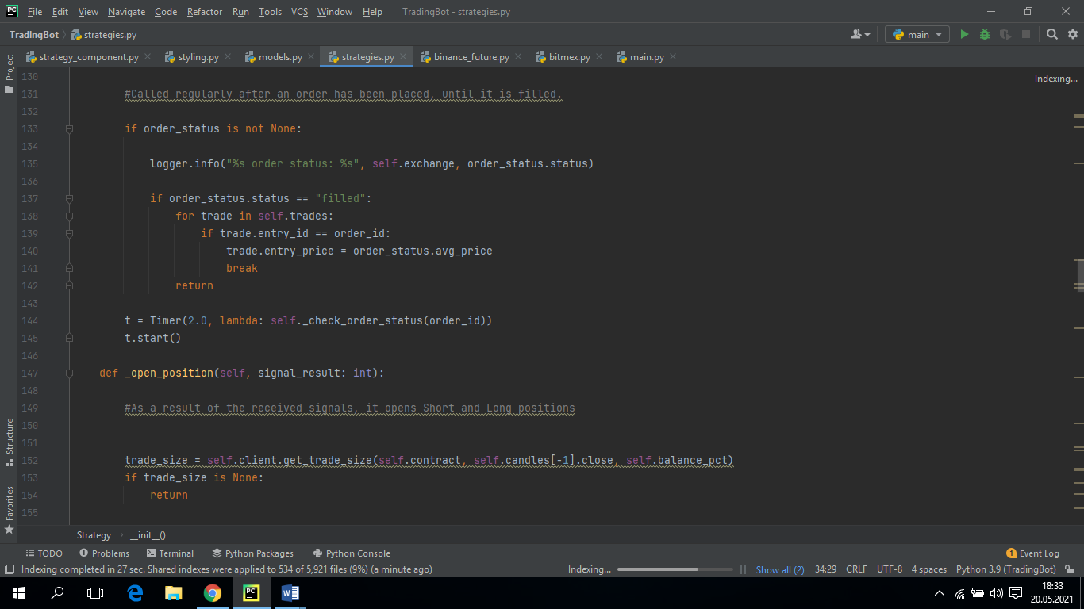

There are 2 positions you can trade in futures. These are long and short. Long position is your prediction considering that the value of the coin will increase. Short is your prediction that the coin will decrease in value. If your Short prediction is correct and the coin is falling in value, you will earn as much money as it drops.

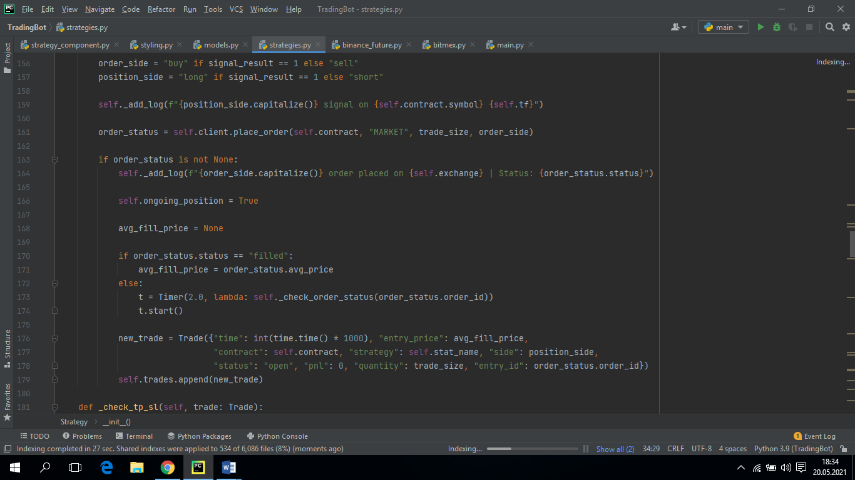 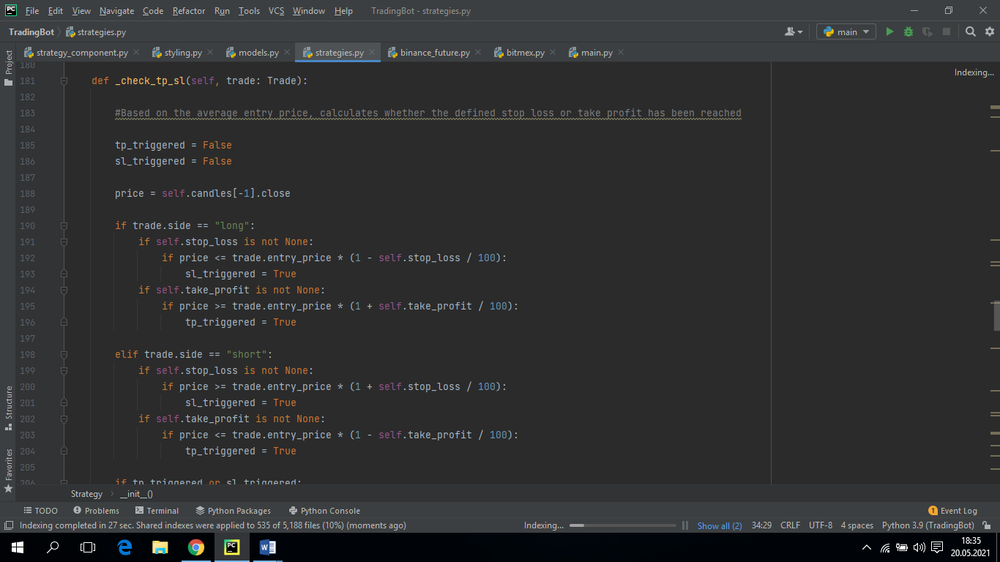

The tp value indicates the vertex you specified. This peak point is the point at which your profit will be taken by stopping the transaction together with your profit if you make a profit. In our bot, we calculate the take profit value as a percentage of the amount we entered. This shows how much we have earned as a percentage instead of entering the price we want to exit.

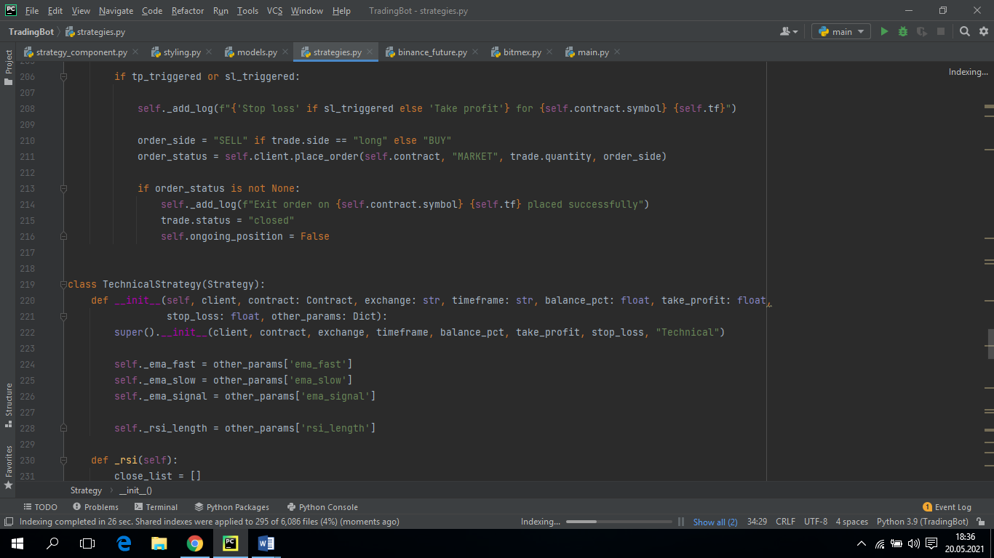

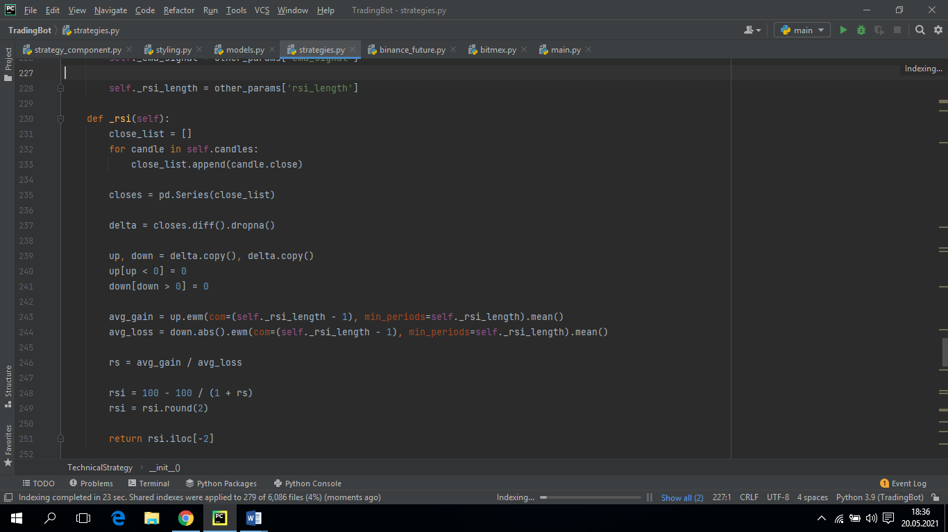 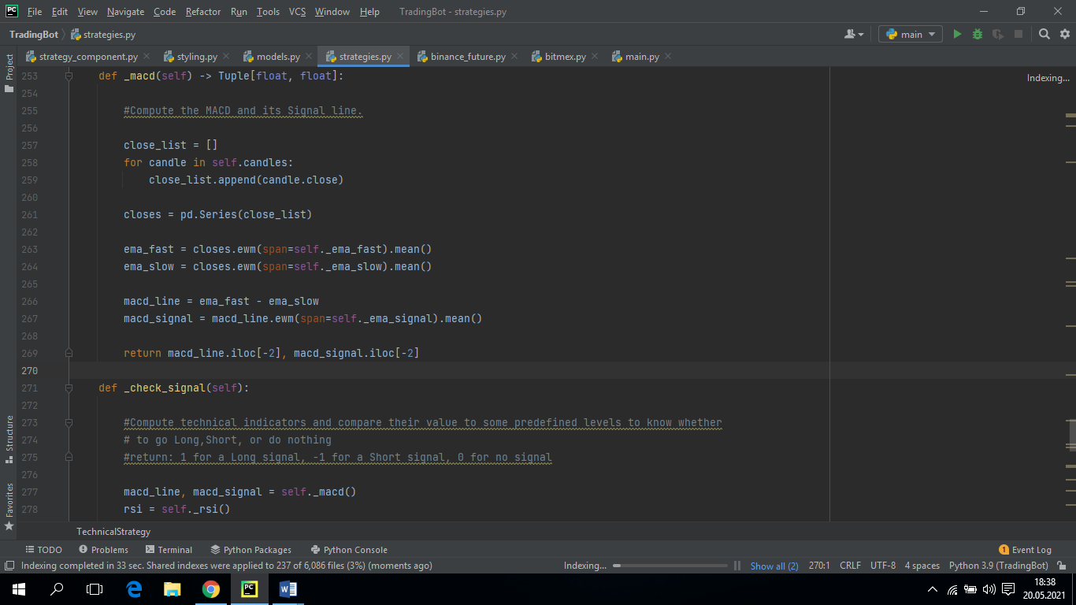

Rsi and Macdi are two different indicators. Moving averages are the easiest basic indicator to examine and understand. These indicators show an average for past days for a certain number of days. Moving averages helps us understand the complexity in the chart. Thus, we can see that the price increases, decreases and remains constant according to the direction of the lines. RSI is a momentum indicator that analyzes overbought and oversold situations in a price histogram. RSI is calculated by a formula. This formula has 2 parts:

RSIstep one = 100 − [ 100 / (1+( Average loss / Average gain )) ]

A standard system first uses a 14-day calculation for the first step. For example, let's assume that these 14 days closed with 1% gain in 7 days and 0.8% loss in the other 7 days. The calculation is as follows:

55.55=100−[100/(1+(-0.8%/14)/(1%/14))]

The second part of the calculation is to smooth the results:

RSIstep two=100−[100/(1+(Previous Average Gain×13) + Current Gain / -(Previous Average Loss×13) + Current Loss)]

After these calculations, the RSI line can be drawn. In this line chart, if there is an increase in the system and it closes positively, the line will rise, and if there is a decrease and negative closure, the line will decrease.

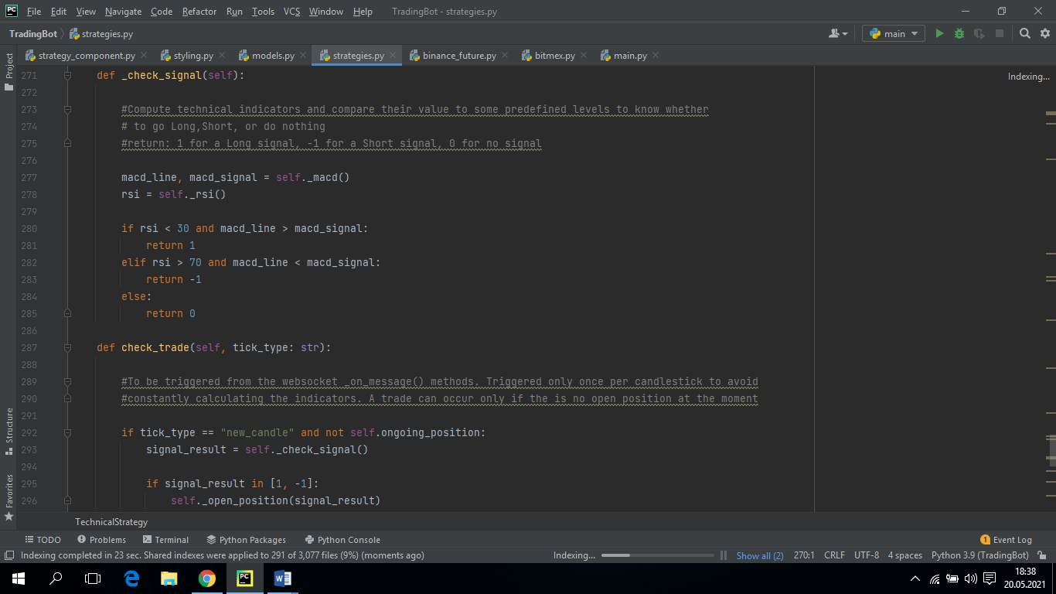

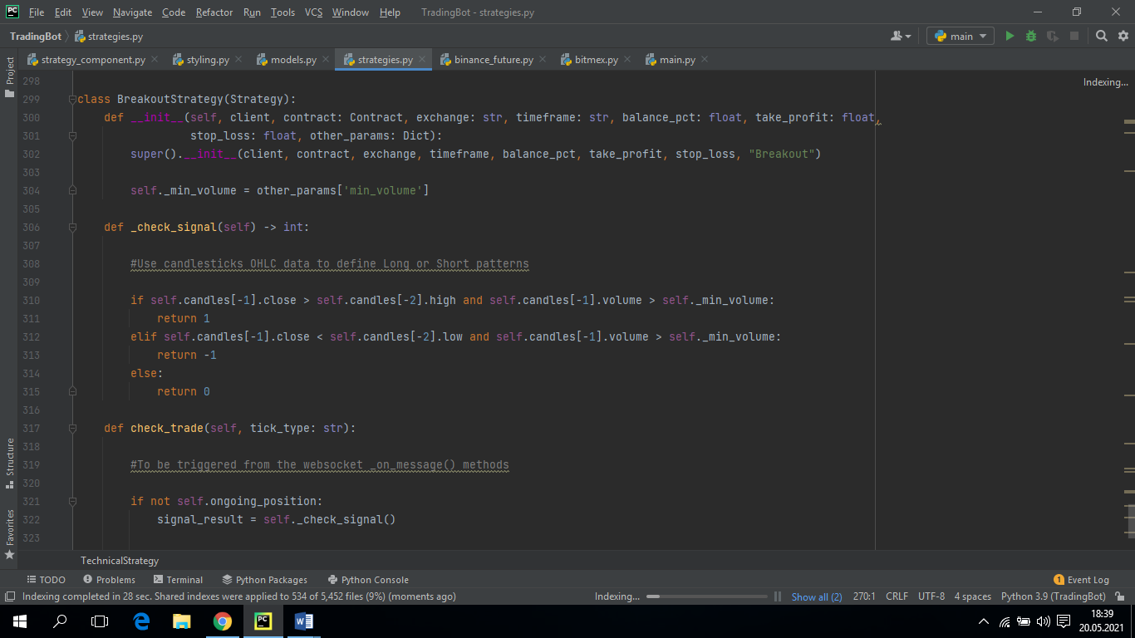

* 1. **Interface Parts**
* **logging_component.py**

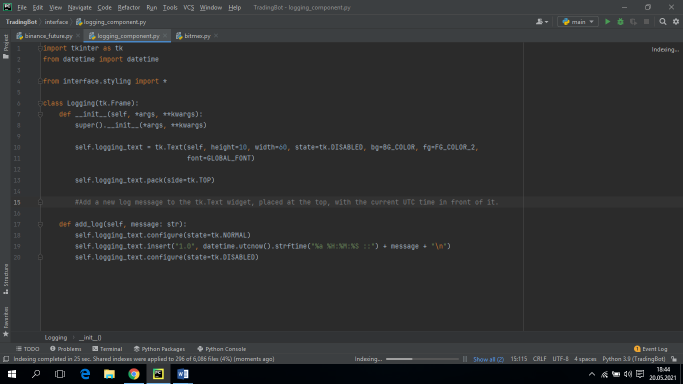

When we have successfully logged in, it notifies us with a message of the platform we are logged in to.

* **root_component.py**

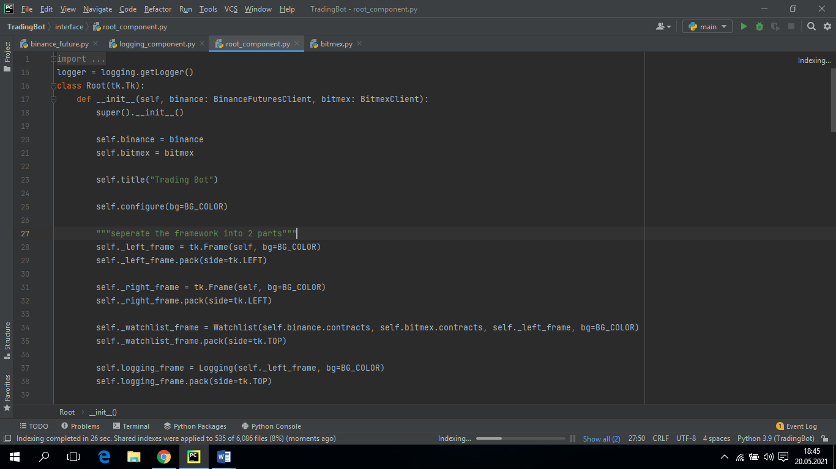

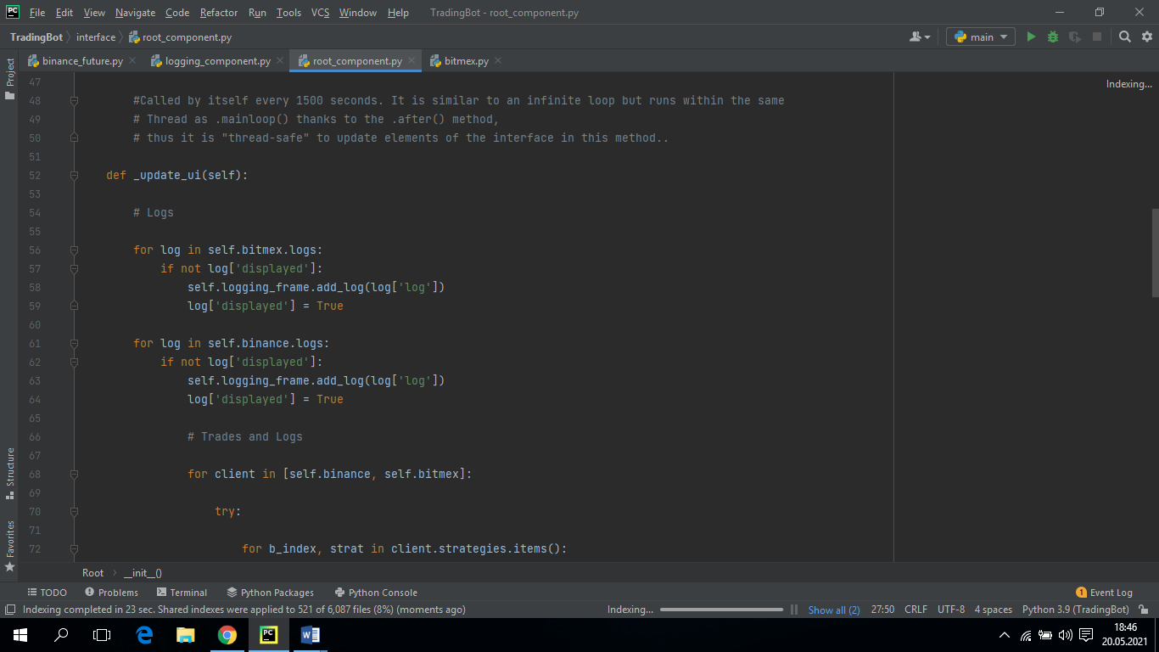 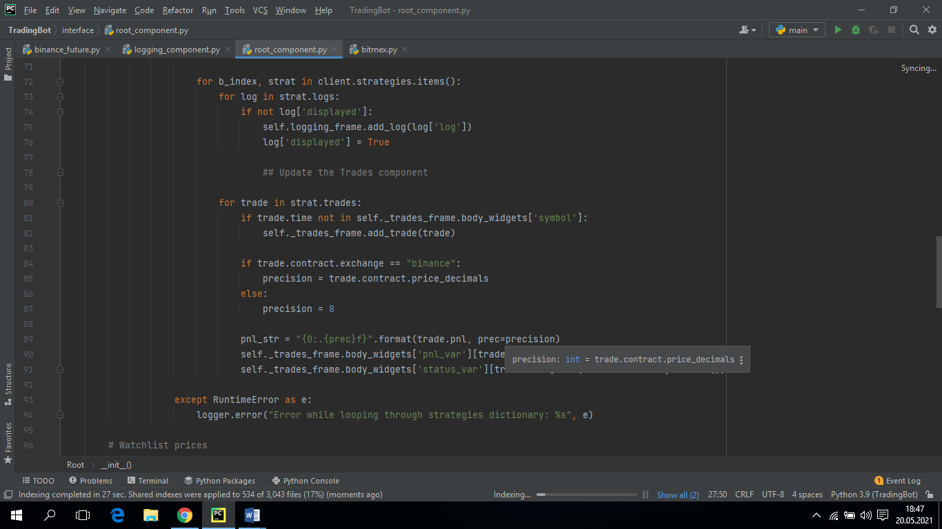

This part forms the left part of the interface. There are two different platforms for us to subscribe in this section. It receives the coins of these platforms that we can subscribe to. If we write the name of the coin and quote that we want to subscribe to in the search section, it will receive the data of that coin as ask and bid. With the updating function of these values, it sends requests every 1500 seconds and takes these values ​​and refreshes the value displayed in the interface.

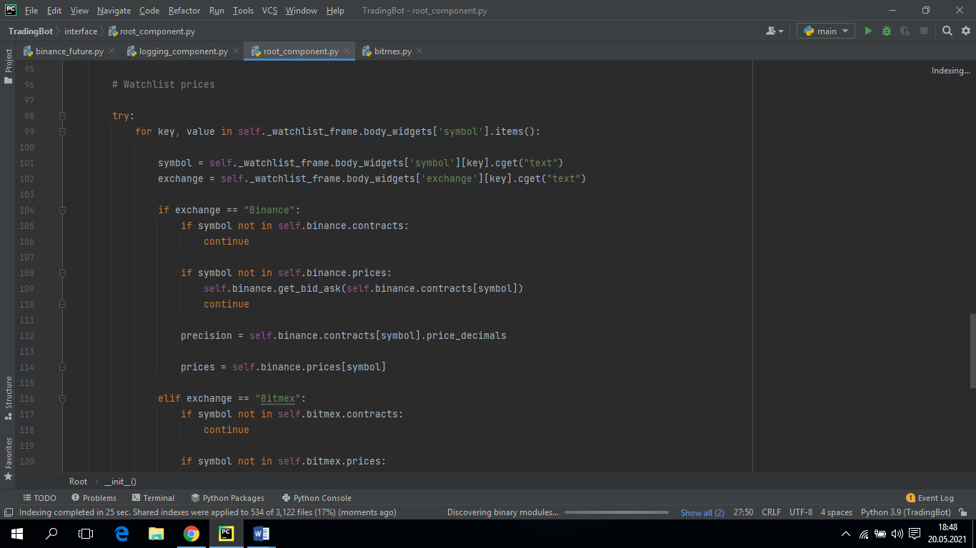 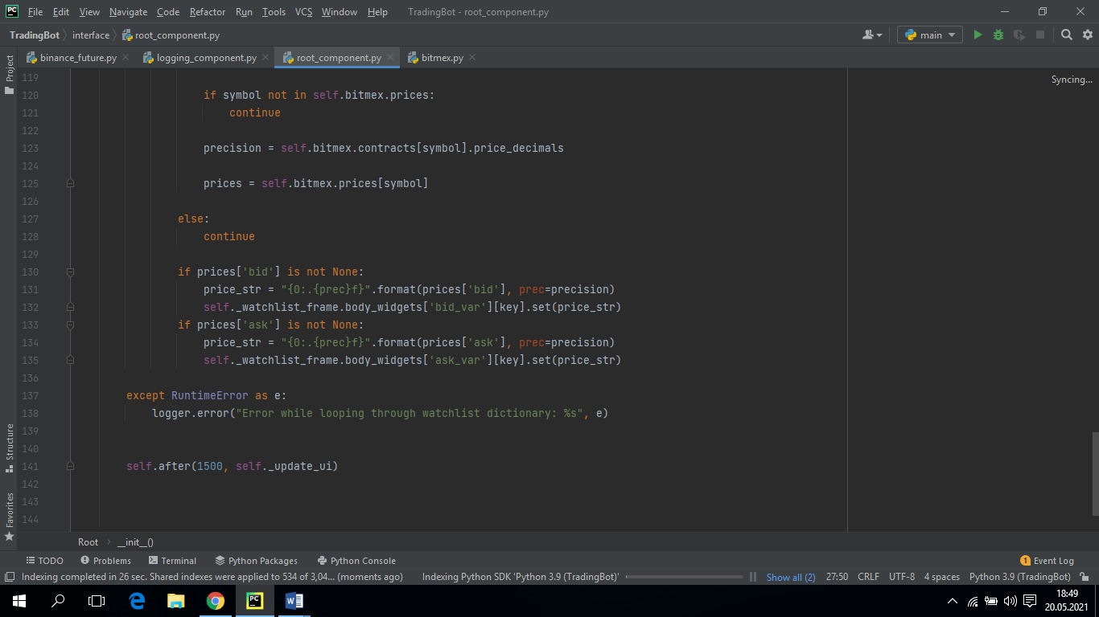

* **strategy_component.py**

In this section, we set up the interface for our two different strategies. First of all, there is a dropdown menu where we choose our strategies. Then the timeline we want for this strategy. We need to enter different parameters for the two strategies. The parameters we will adjust according to the strategy we choose vary. The stop loss and take profit values ​​that we will add to our strategy are also added in this section.

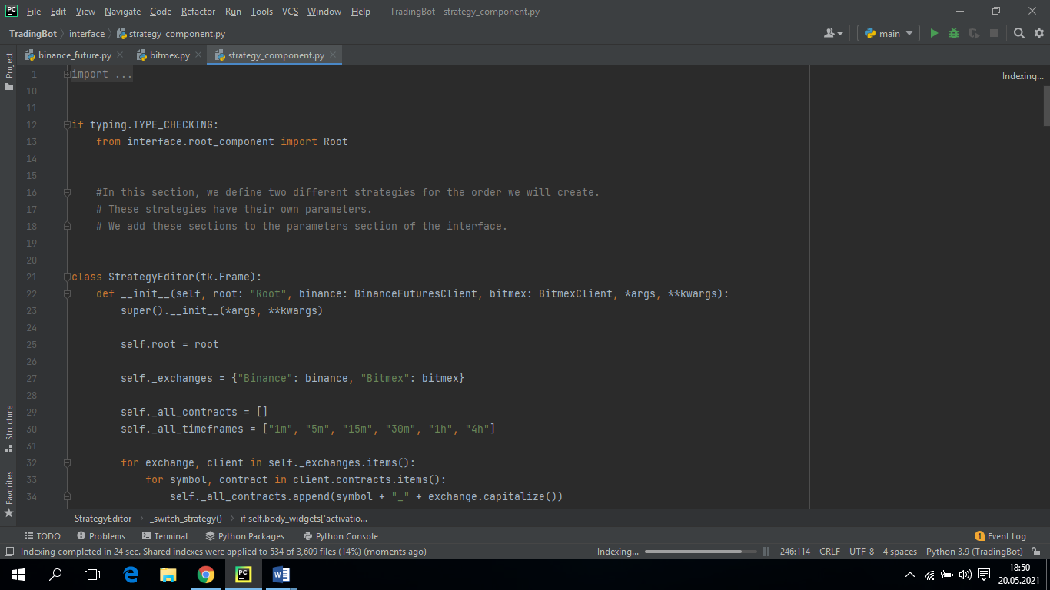

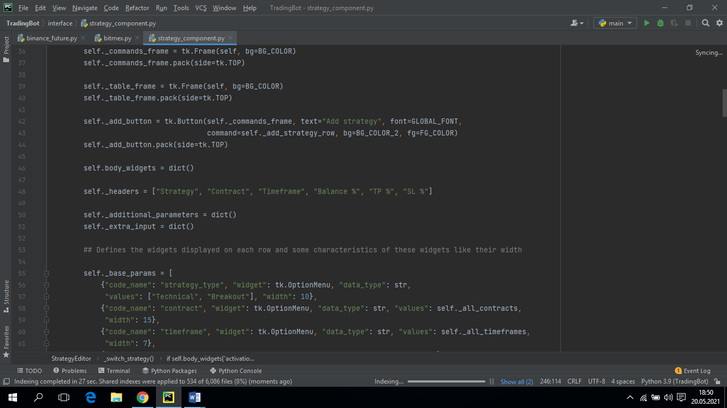 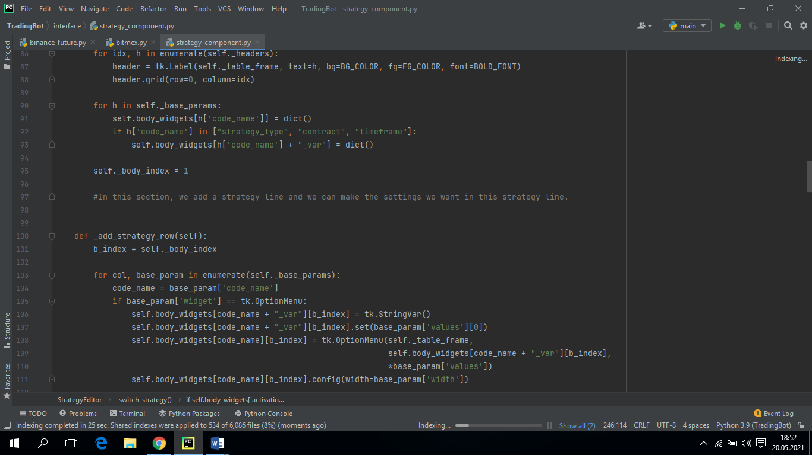 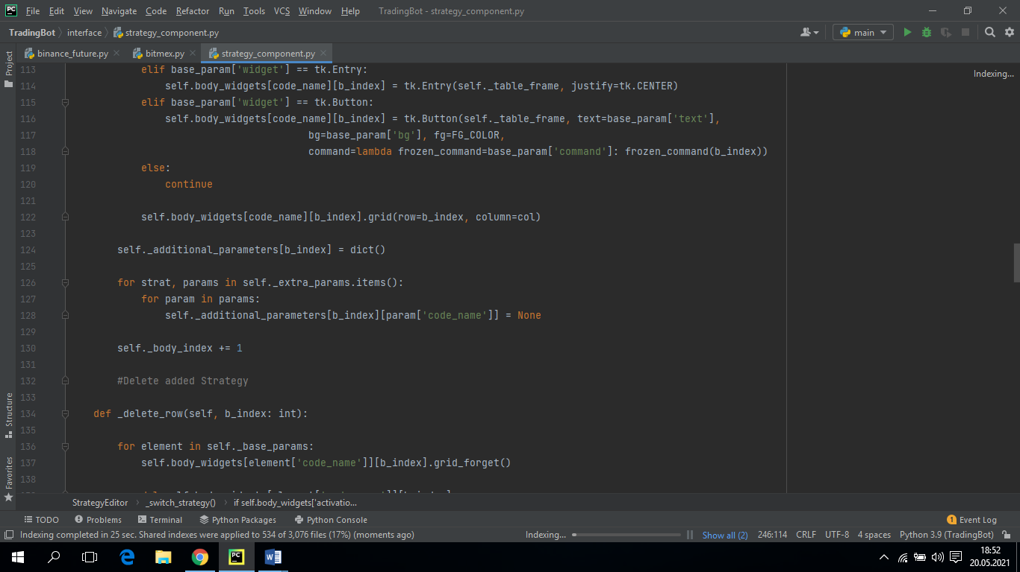 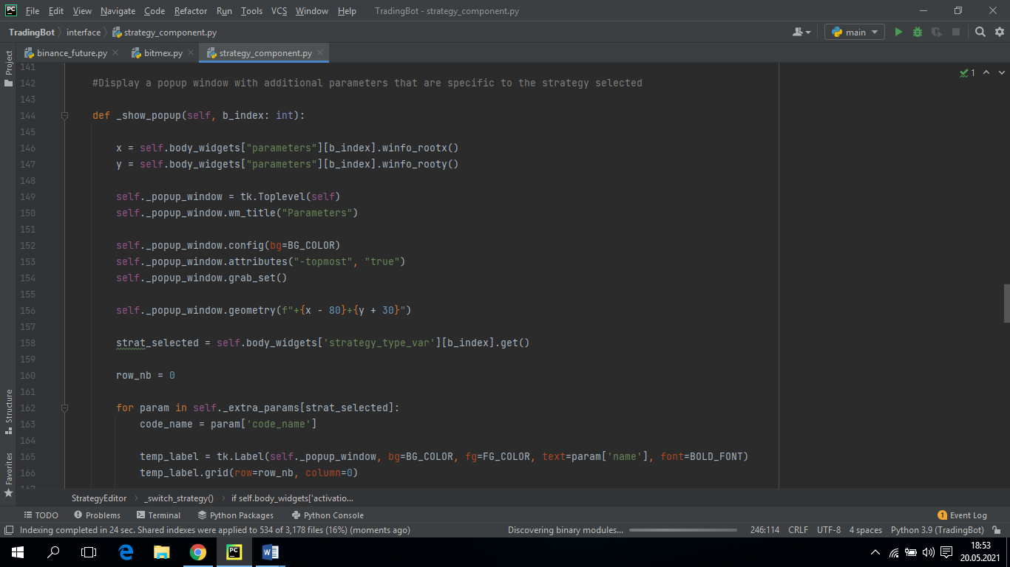 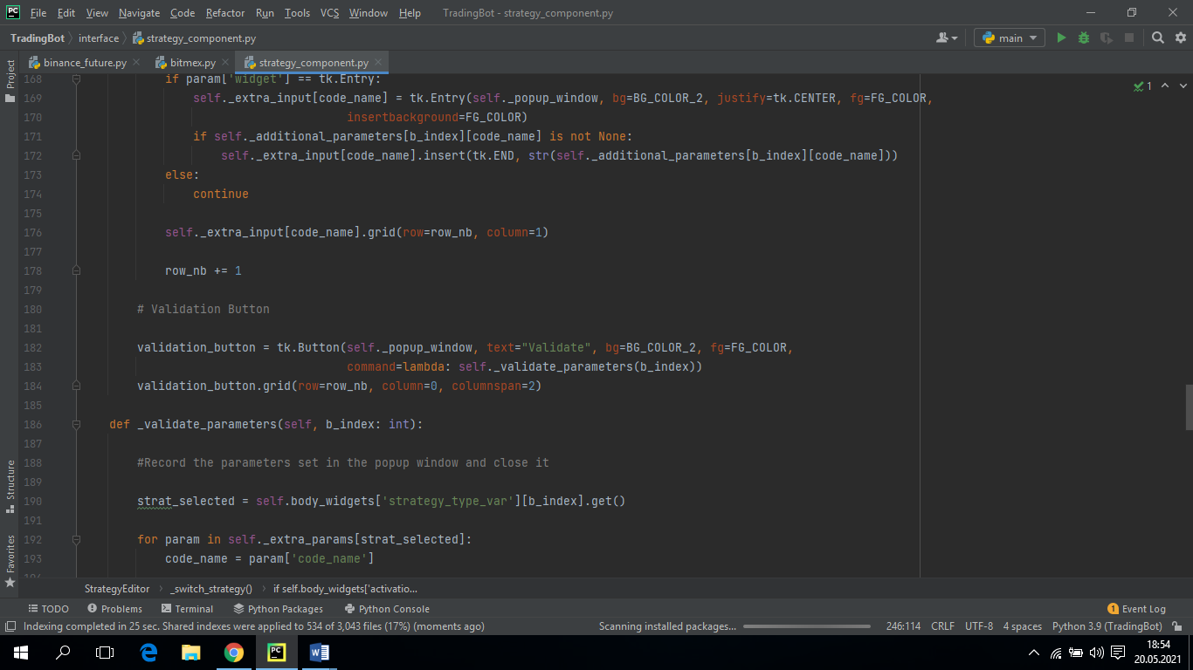 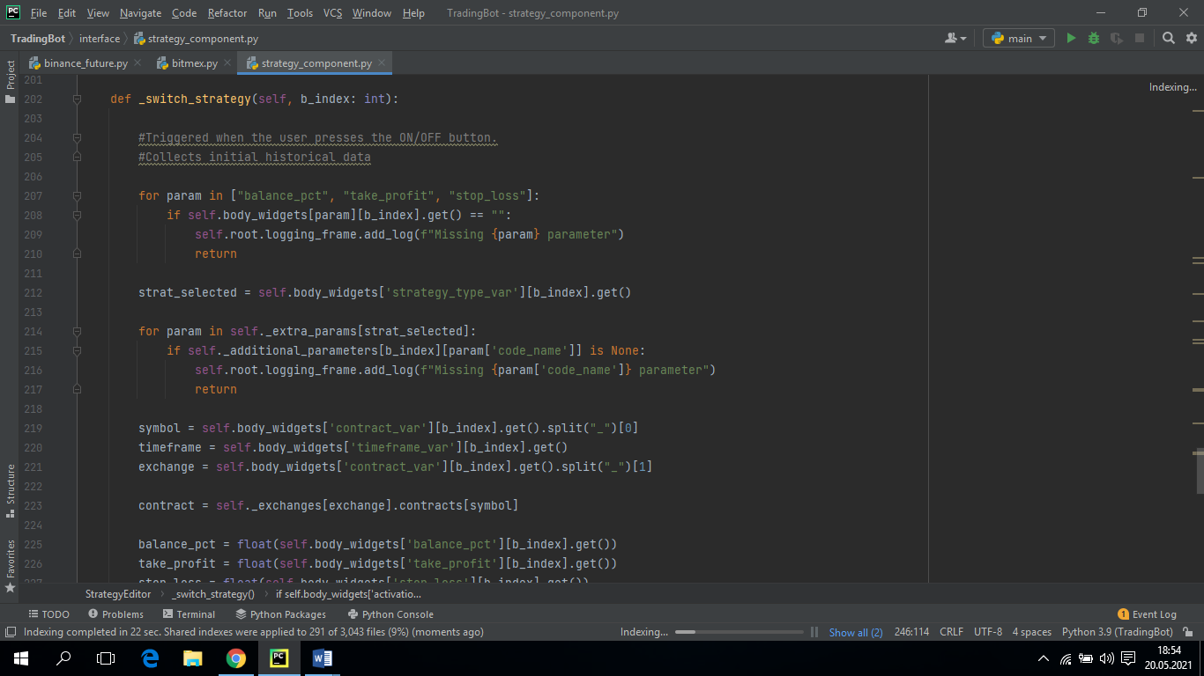 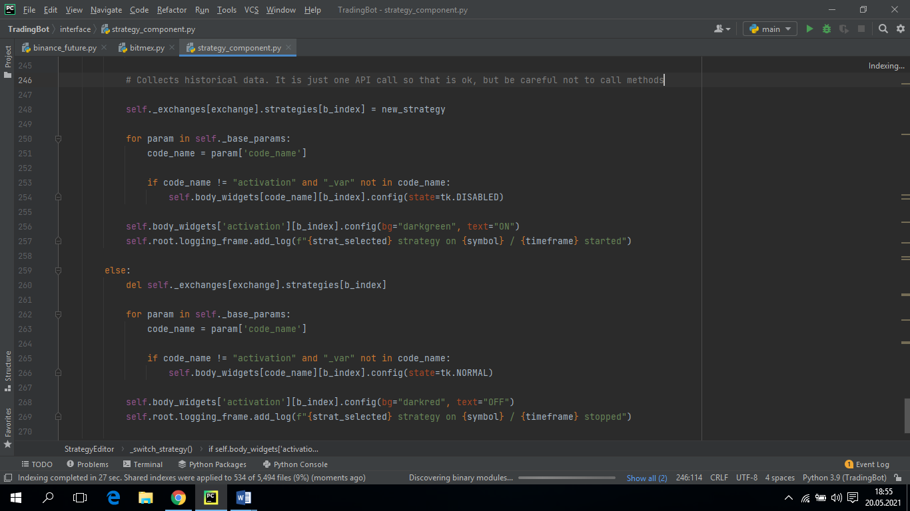

* **trades_component.py**

In this section, it is a feedback interface that will show us the results up to date after opening a position. This interface shows the coin name, time, position, status, pnl amount. If you are still trading with the strategy you added, your status is open. If you are losing money from the money you started trading, the value in the PNL part will be negative. The side part also shows that you are in a long or short position. If the bot thinks that the coin you are trading will increase, it will enter in long position.

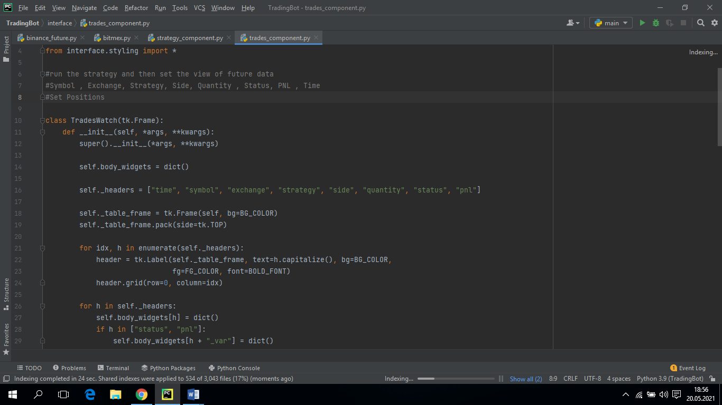

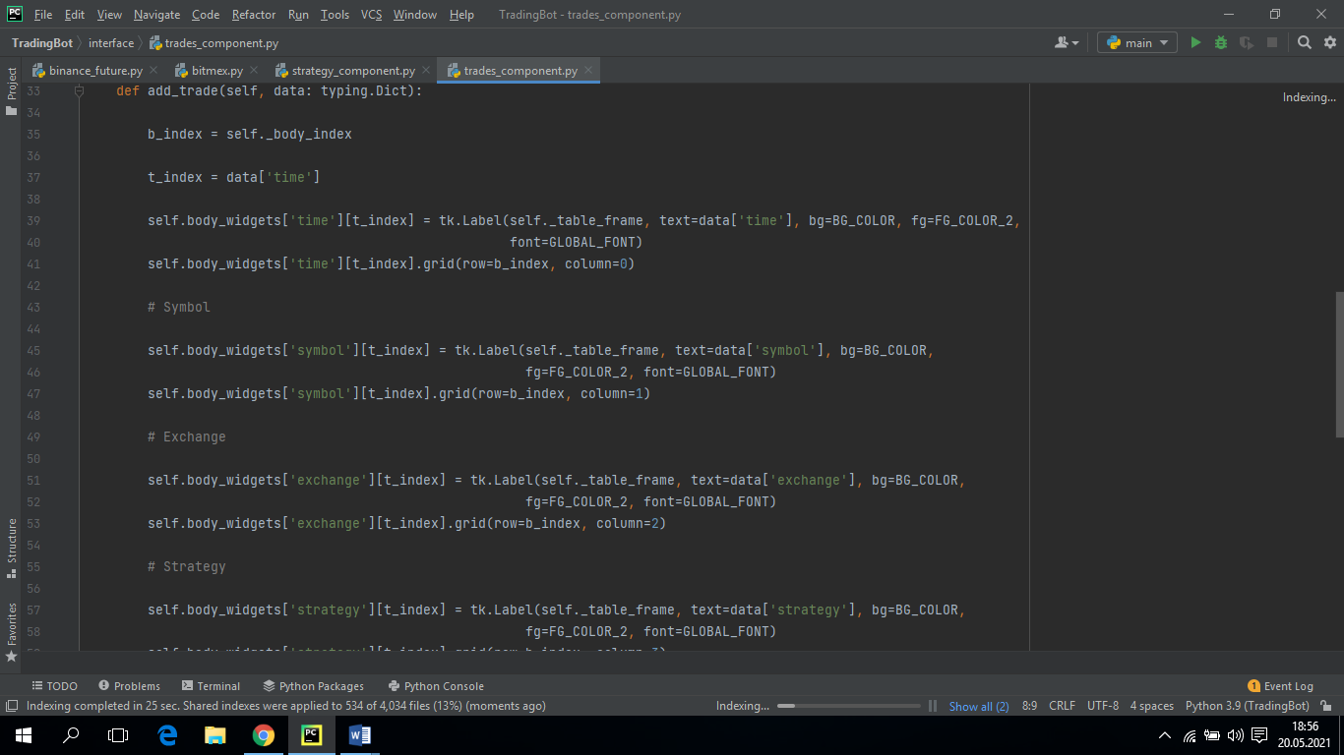 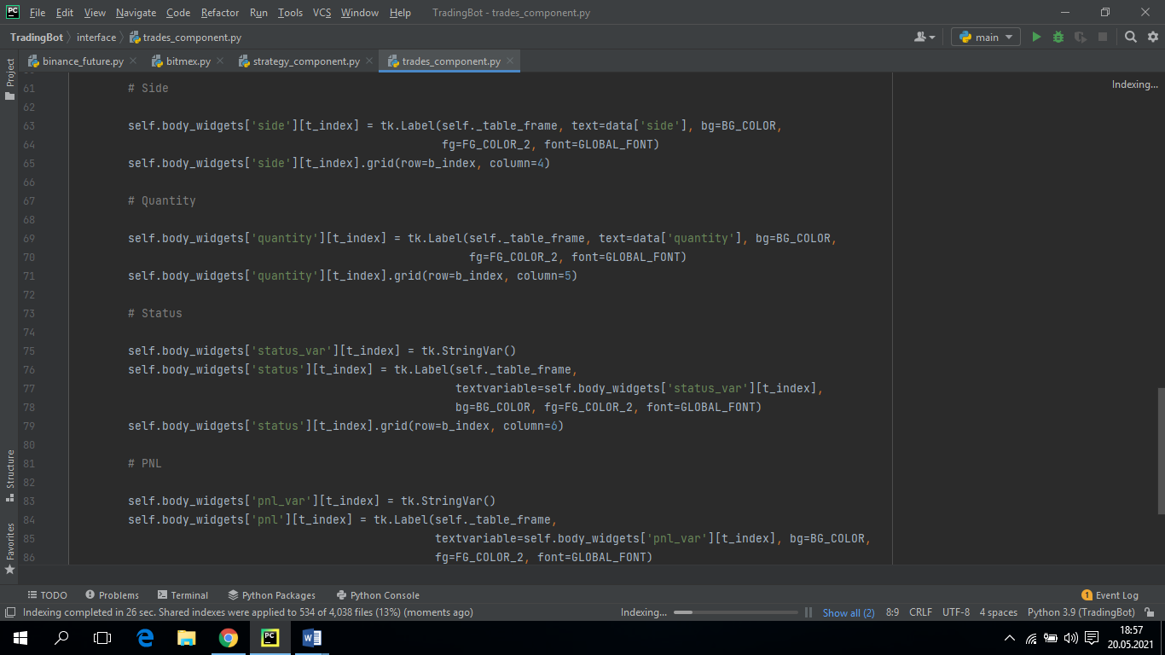

* **watchlist_component.py**

The Wachlist part is also a feedback part. In this section, you will see the amount of purchase and sale that your transactions started, the notifications of when you left the position and when you entered. This part is located under the subscribe part on the left. In this section, there are also the settings of the interface of the subscribe section. There are symbol, contract, bid and ask headers. There is also a remove button to cancel subscriptions.

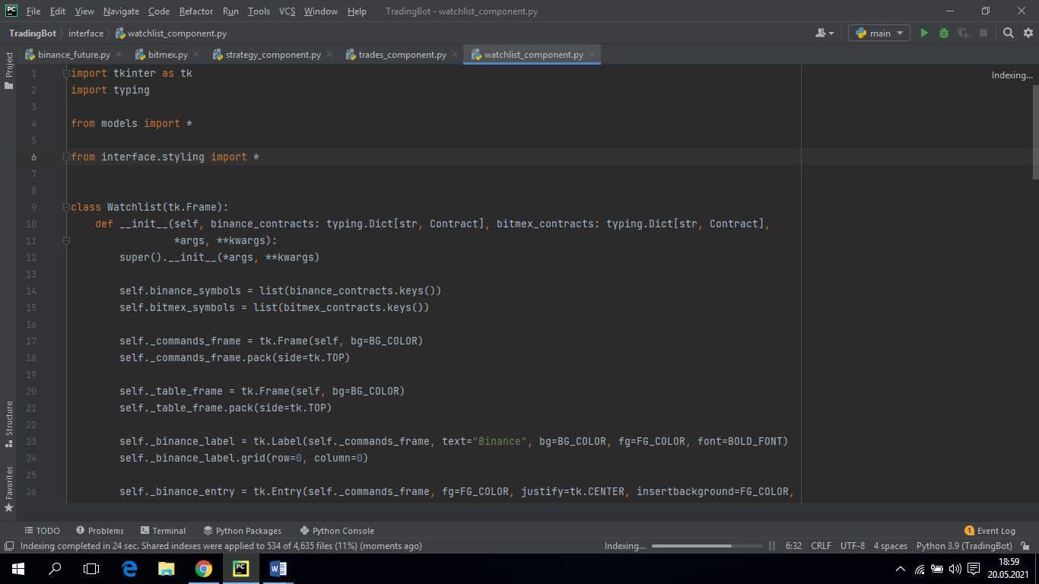 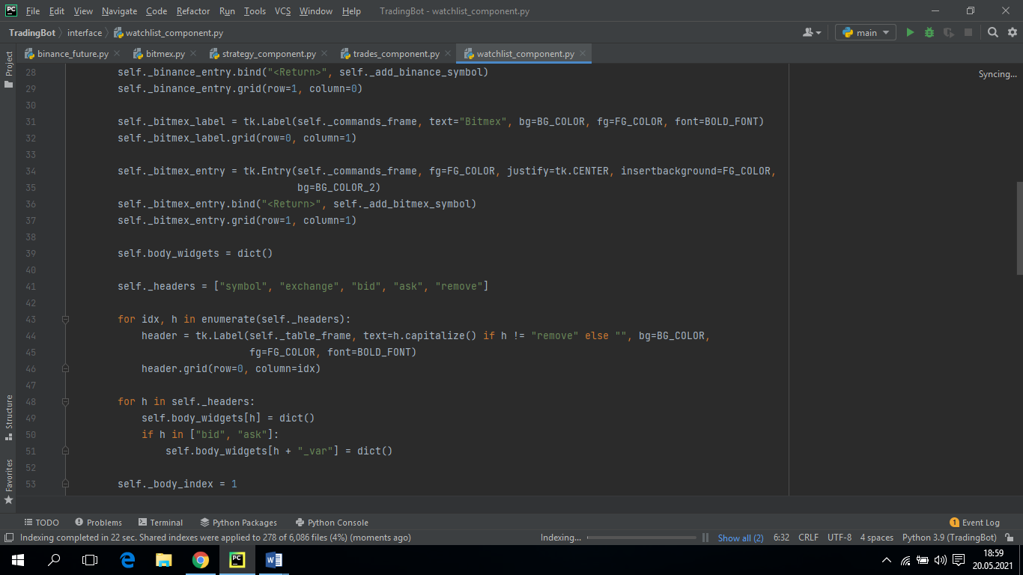 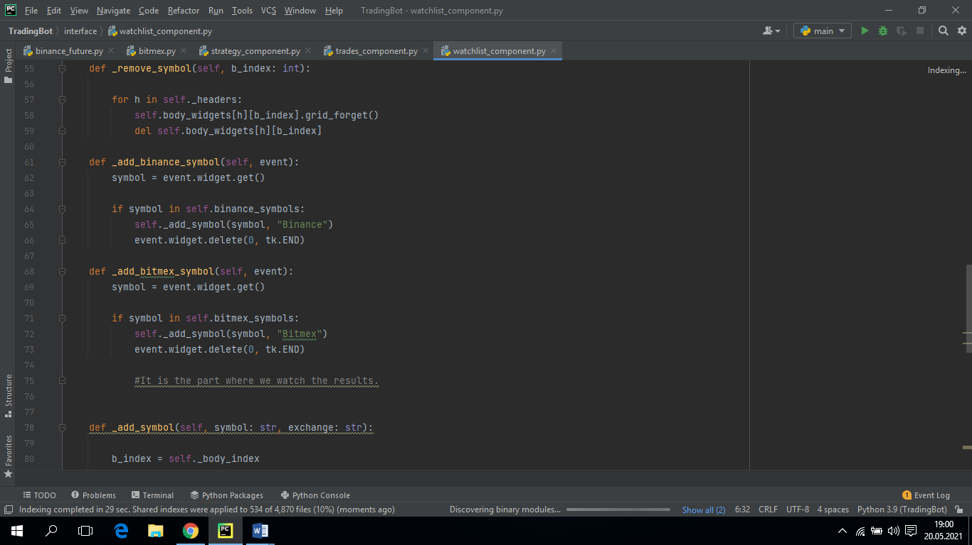 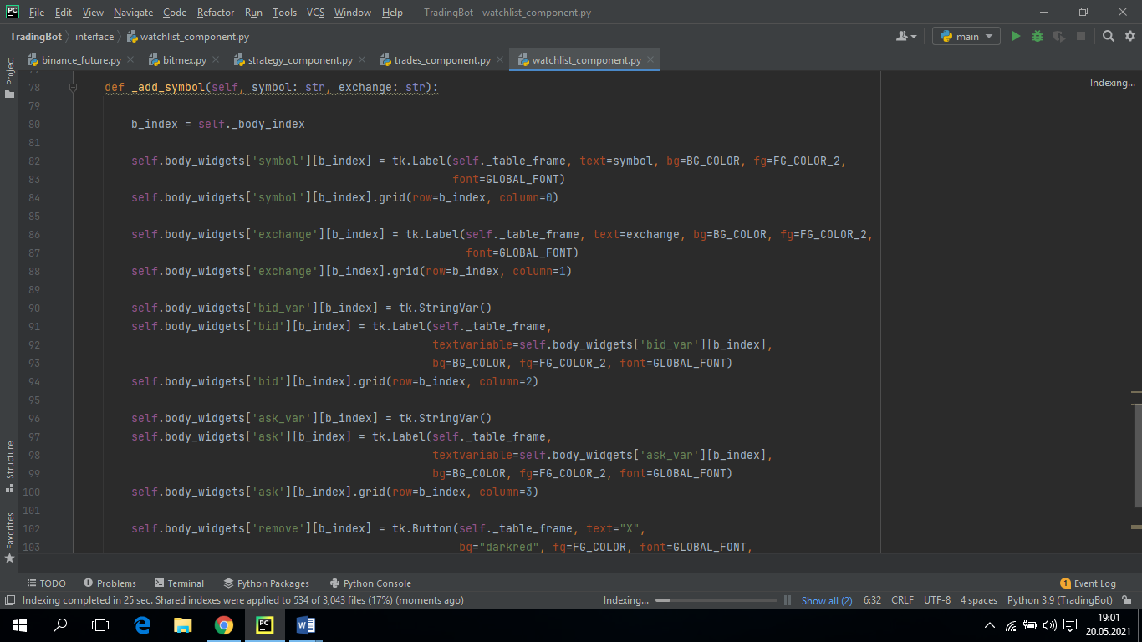

* 1. **Connectors Parts**
* **binance_futures.py**

In this section, we get help from the binance documentation site to connect to our binance account and get data. This site provides you with data that you can perform operations such as order, login, request of a program you make.

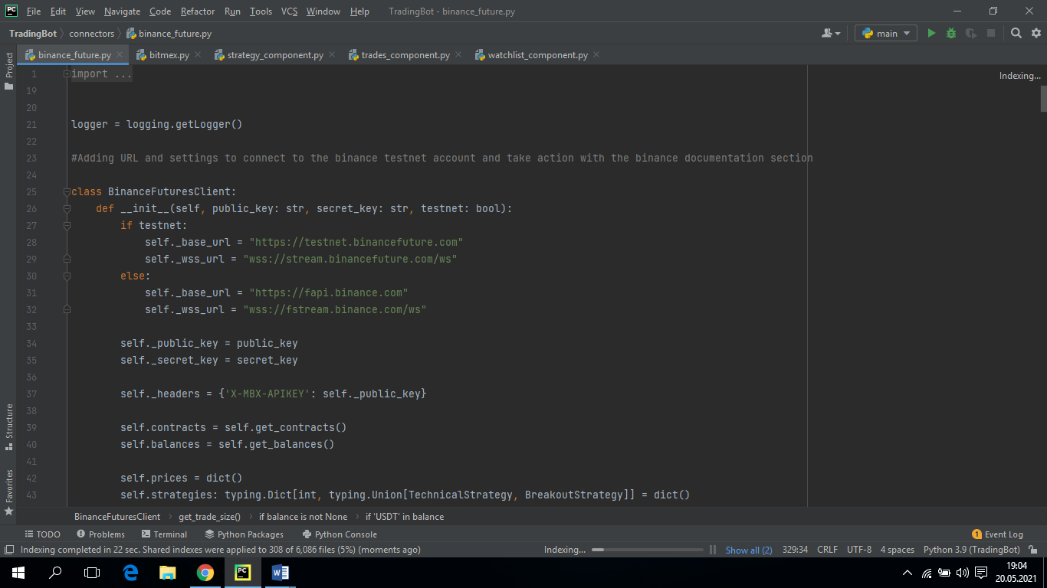

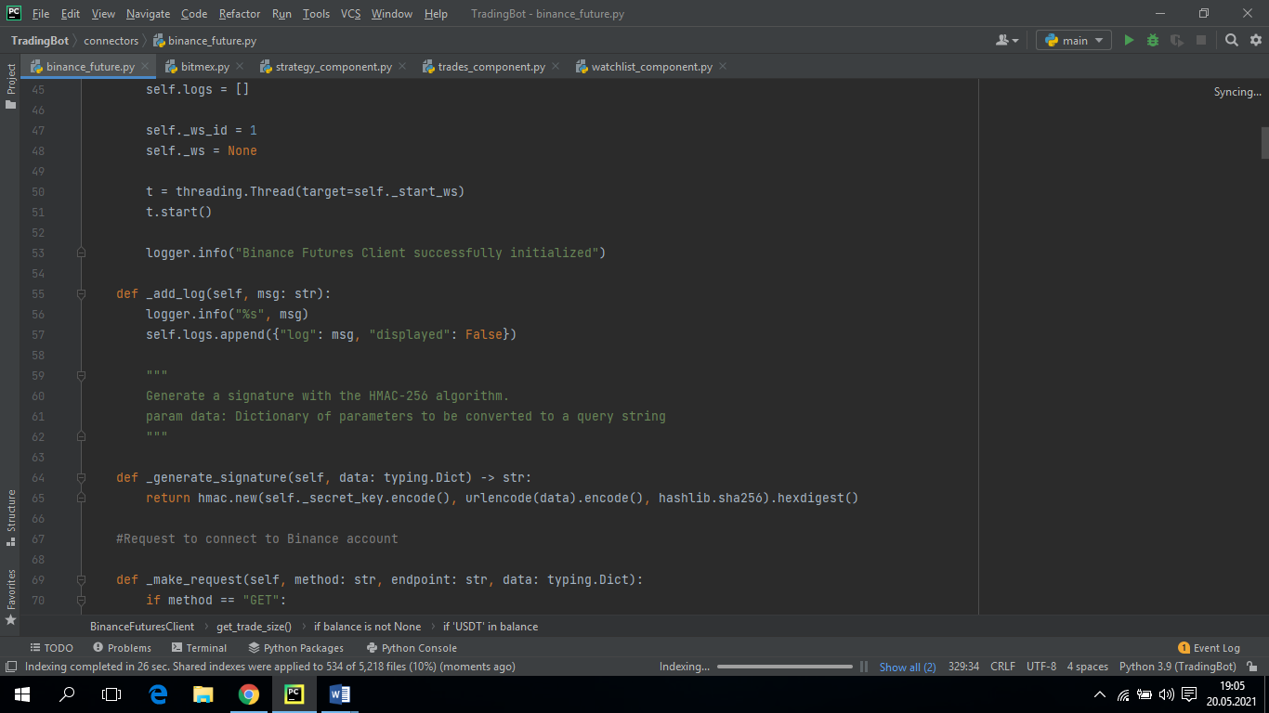 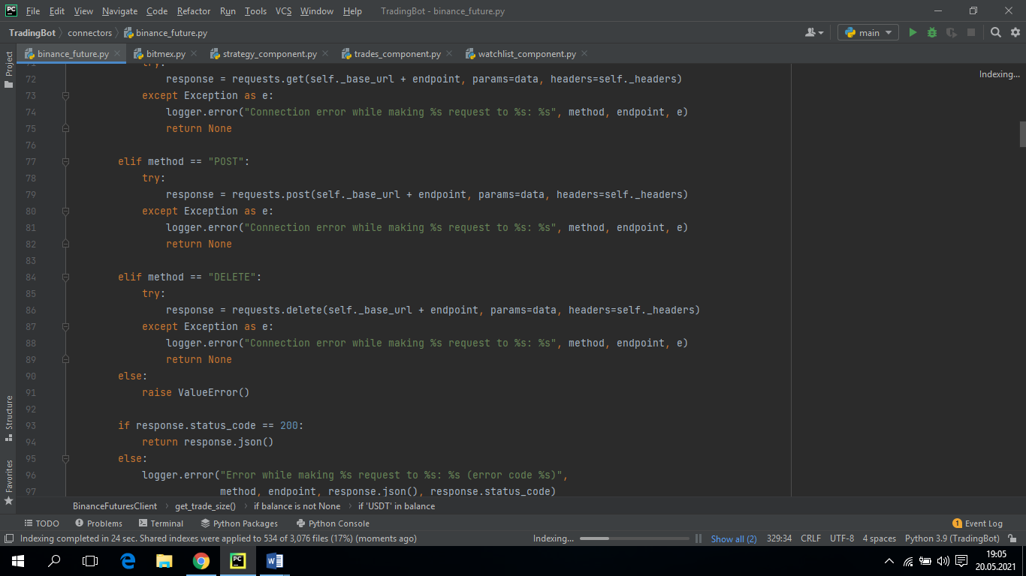 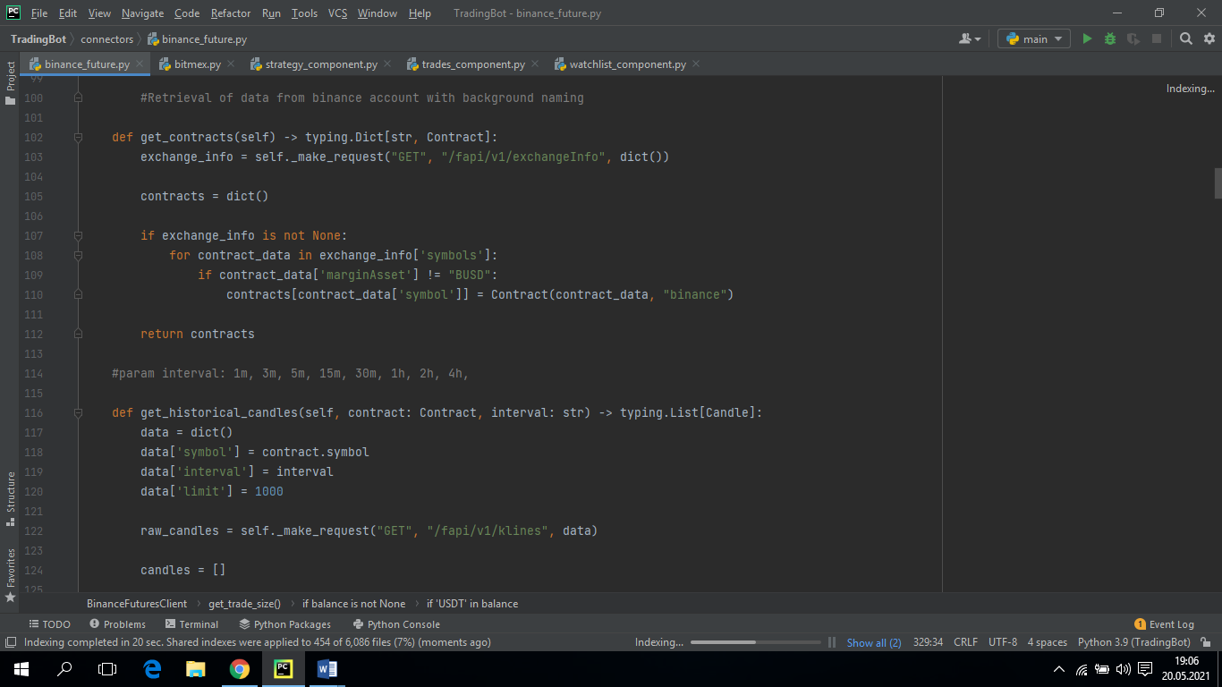 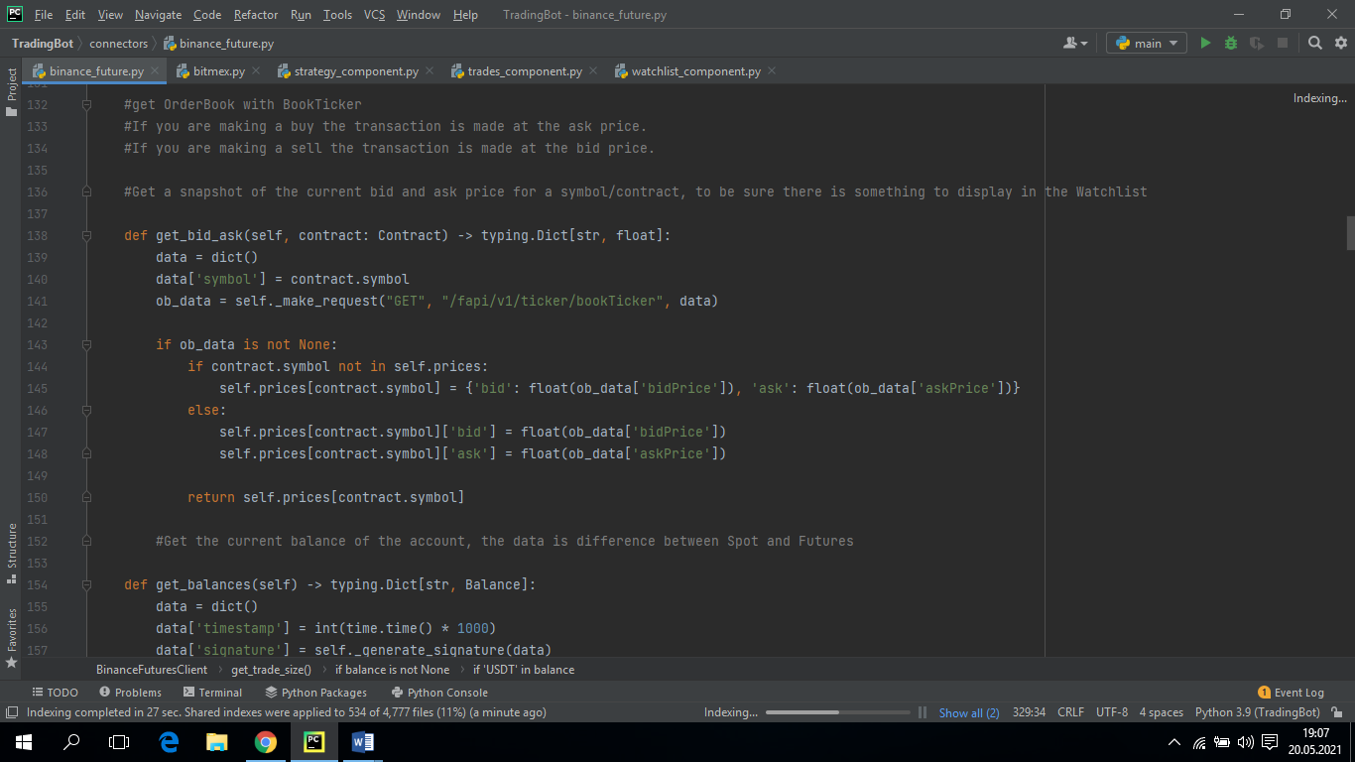

Documentation fabi / order provides order opening and deletion operations.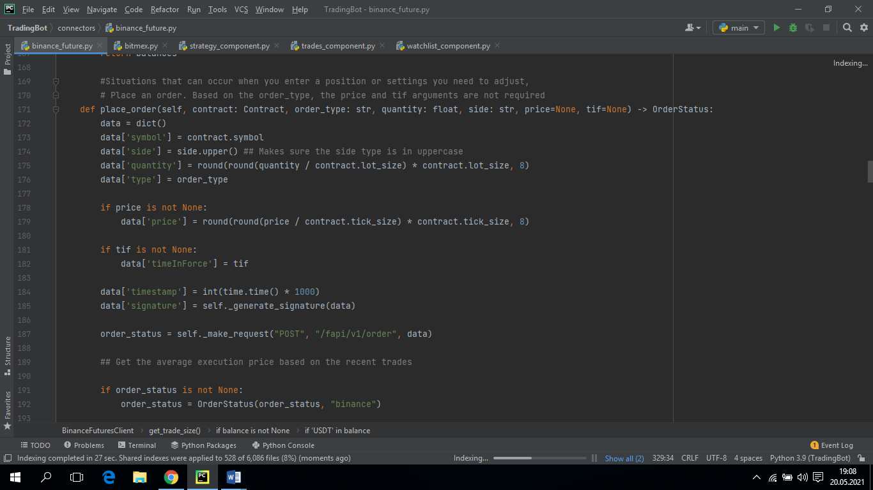 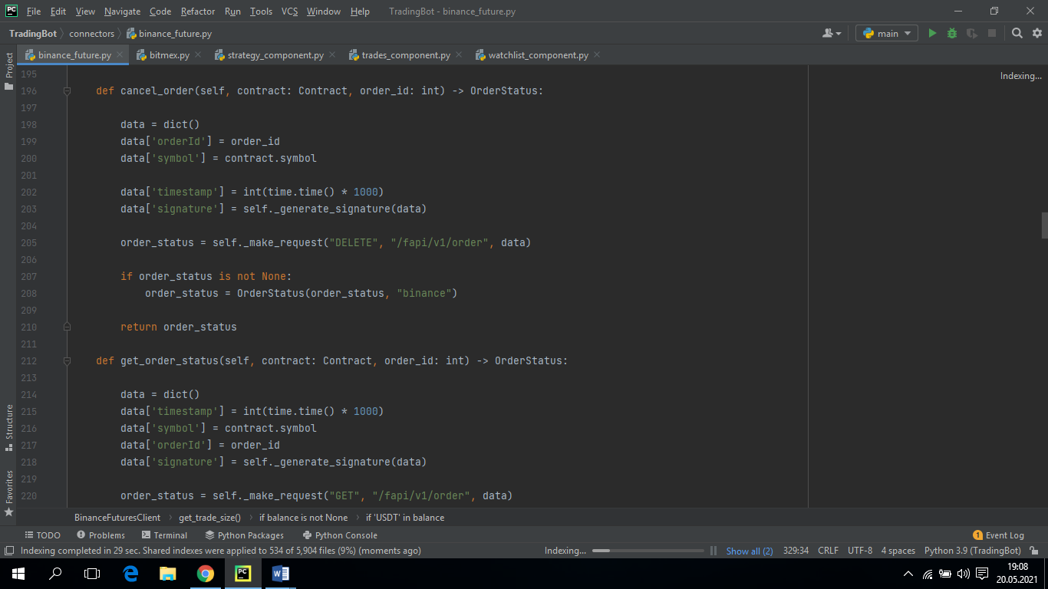 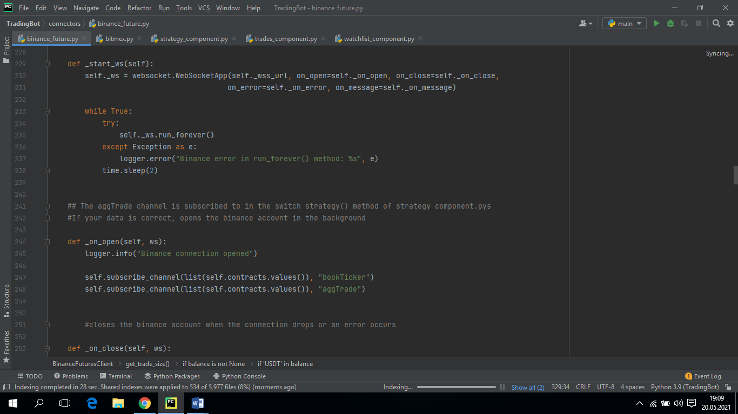 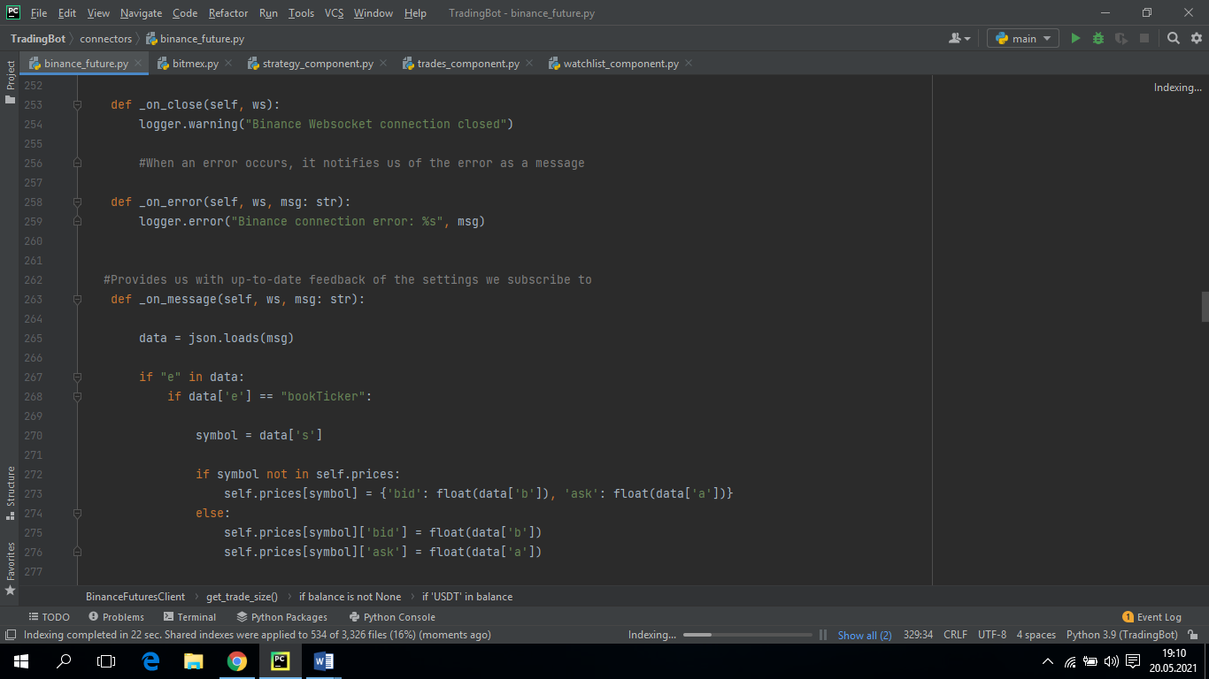 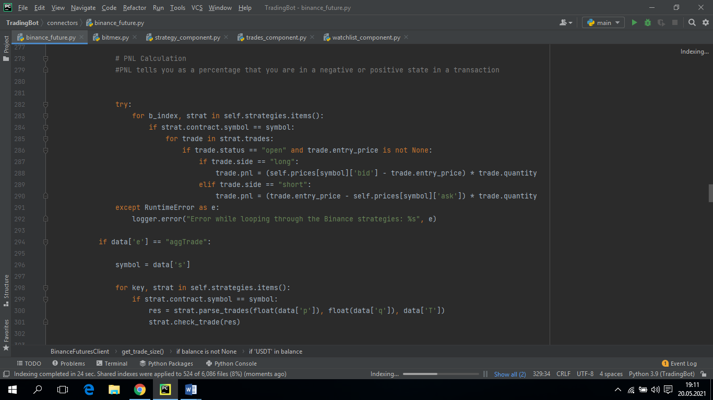 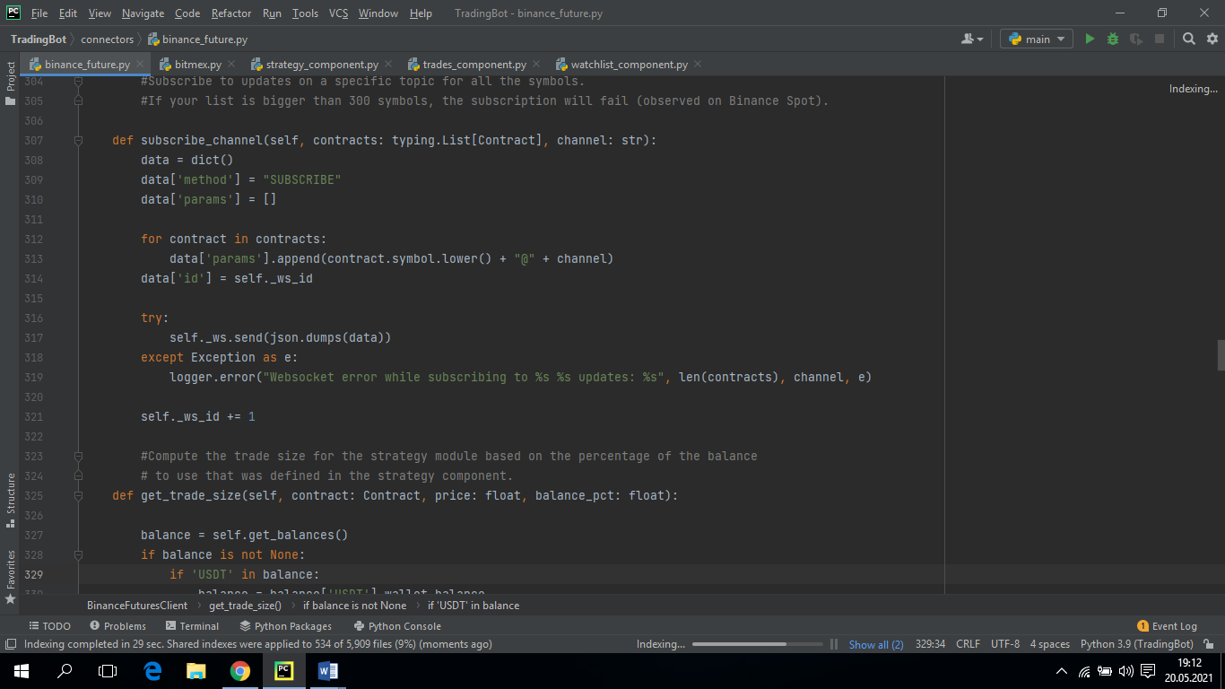

* **bitmex.py**

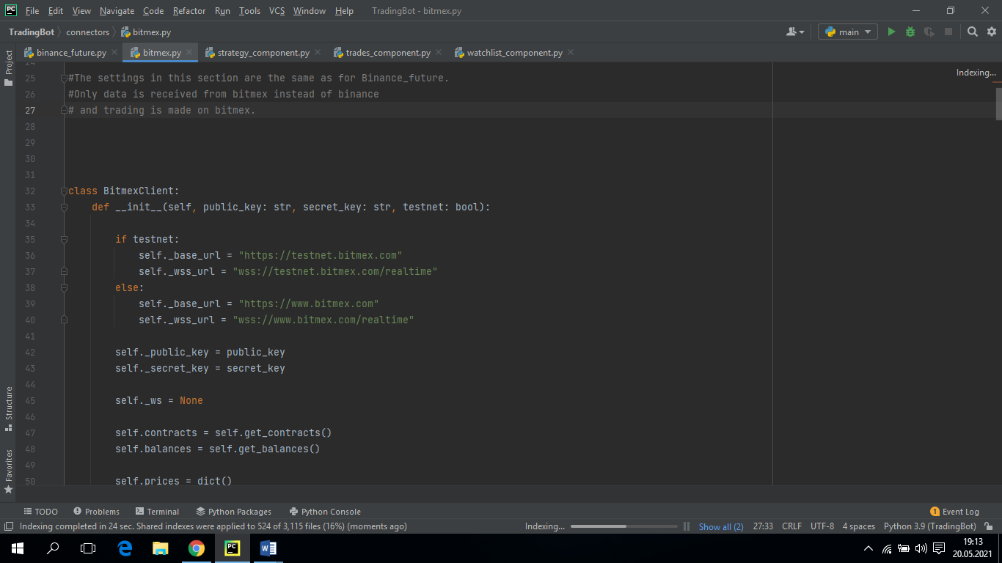

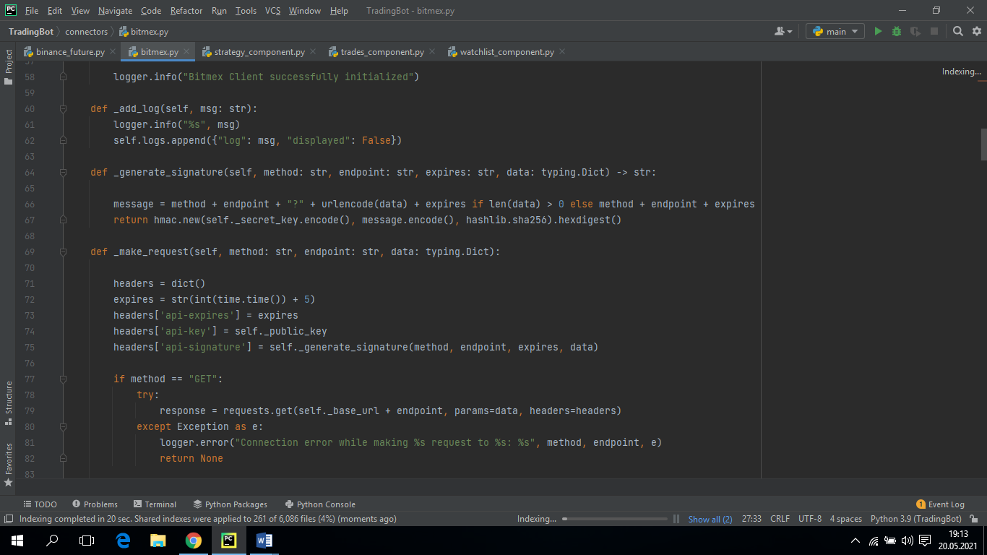

1. **Mockups and Documantation for The Working Interface**

Figure 1 contains a search button for Binance and Bitmex. In this section, the type of coin to be subscribed is searched and then subscribed. Subscribed coins appear at the bottom. At the same time, you are viewing the ask and bid values ​​of the coins you subscribed to together. These two prices vary according to the purchase and sale process.

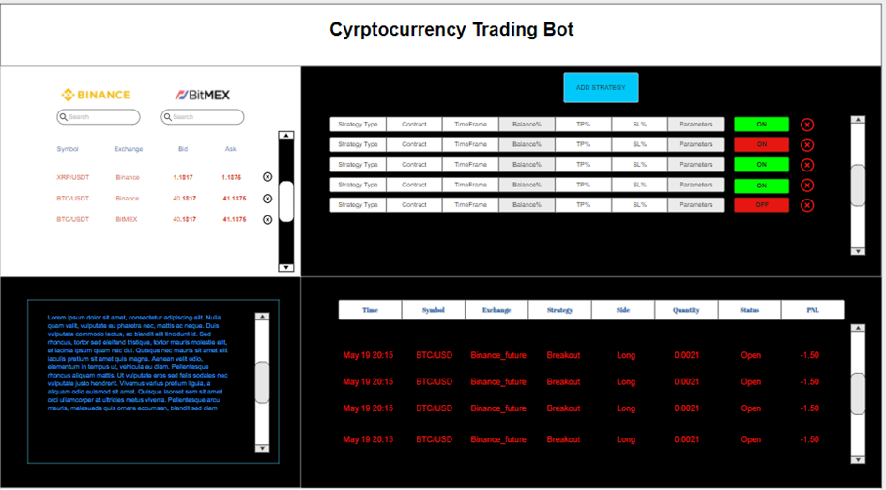

**Figure 1.** Subscriptions

Figure 2 shows the strategy insertion part. From this section, you can start your trade by entering a take profit, stop lose and balance value for your strategies. If the ON button is active, you are in this process and you cannot make any changes on the strategy. But if the OFF button is active, this means your process has not started yet. After making the necessary changes, you can start the process.

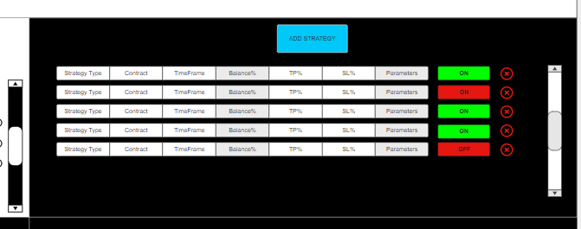

**Figure 2.** Add Strategy

Figure 3 is a feedback of your trading transactions. If the bot has made a purchase or sale for you, you can follow it from this section. This section also shows the short and long positions. In this section, you can see the amount you have won or lost, and you can follow your loss or profit.

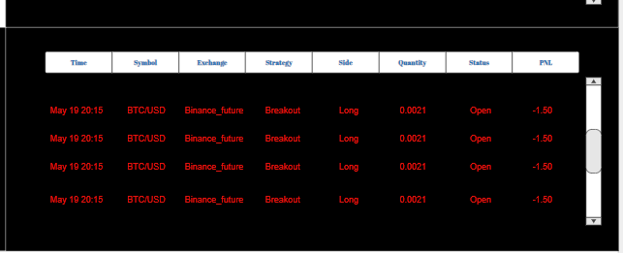

**Figure 3.** Execution Results

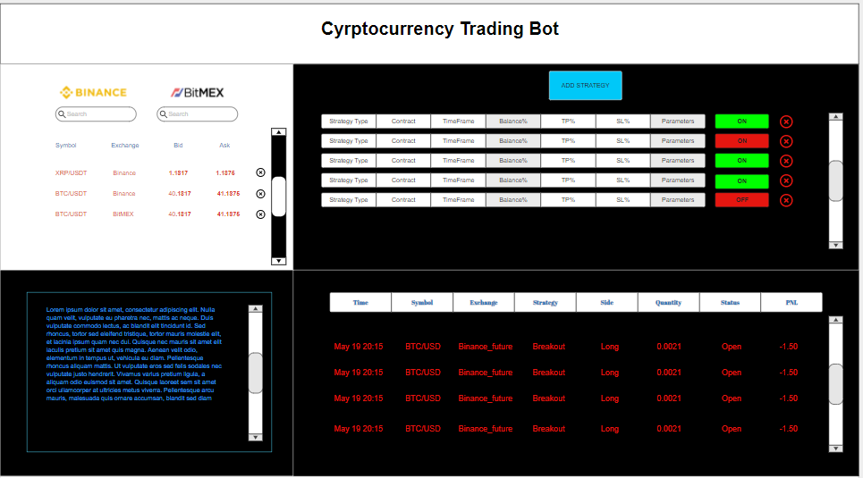

**Figure 4.** The Entire Interface

1. **Test and Experimentation**

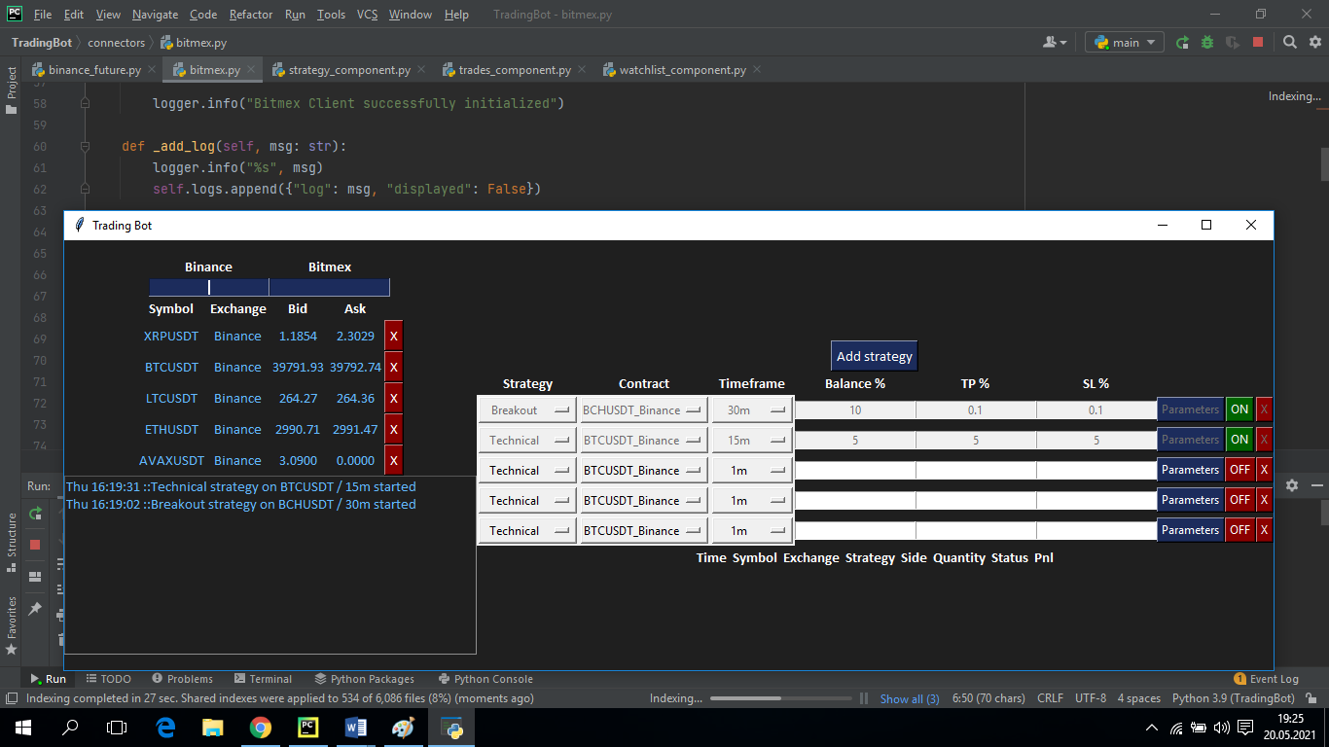

**Figure 5.** Program Output

Figure 6 shows the strategy types we can choose. Figure 7 shows a list where we can choose the types of coins we want to trade.

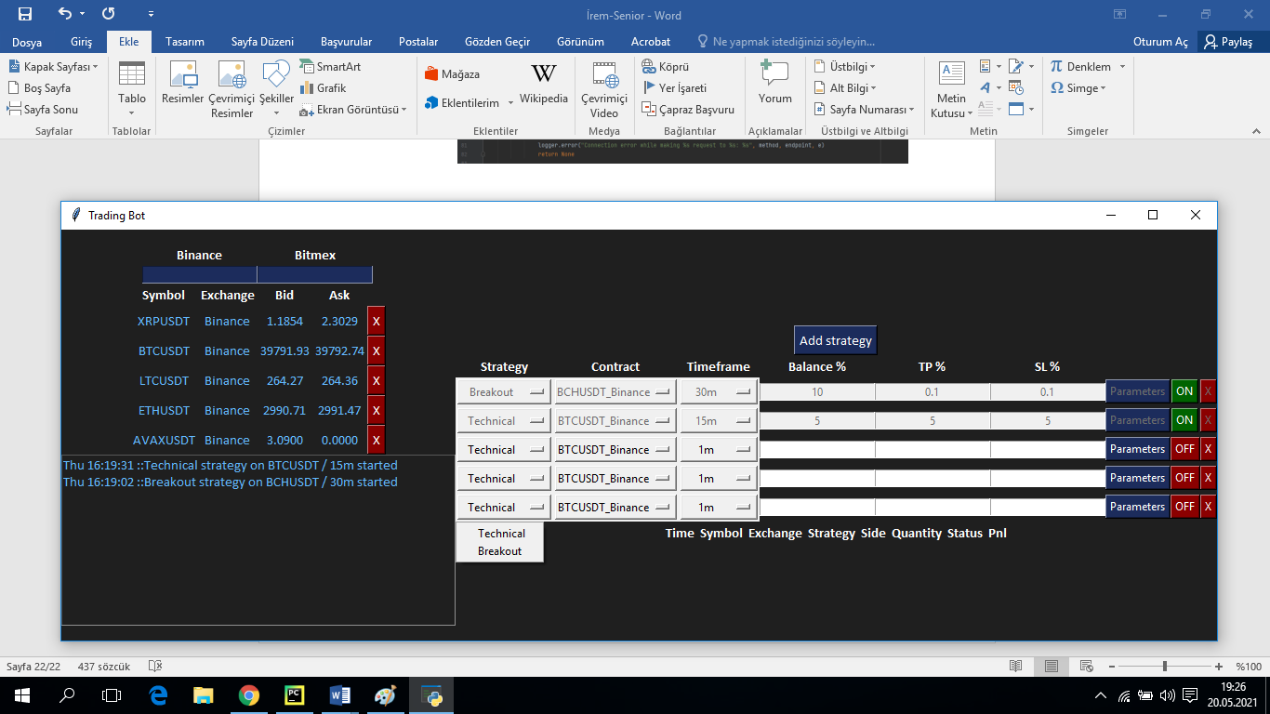

**Figure 6.** Choosing Strategy

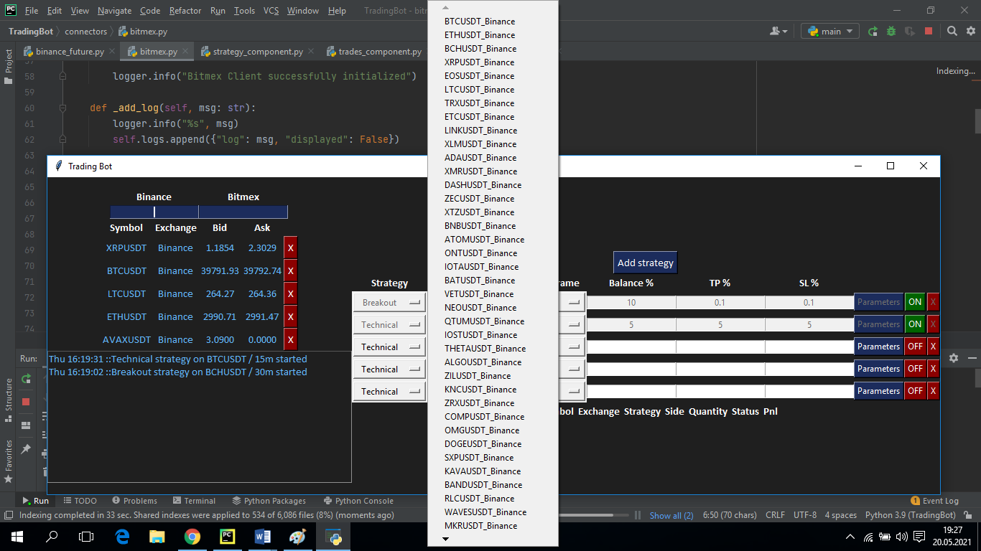

**Figure 7.** Choosing Type of Coin

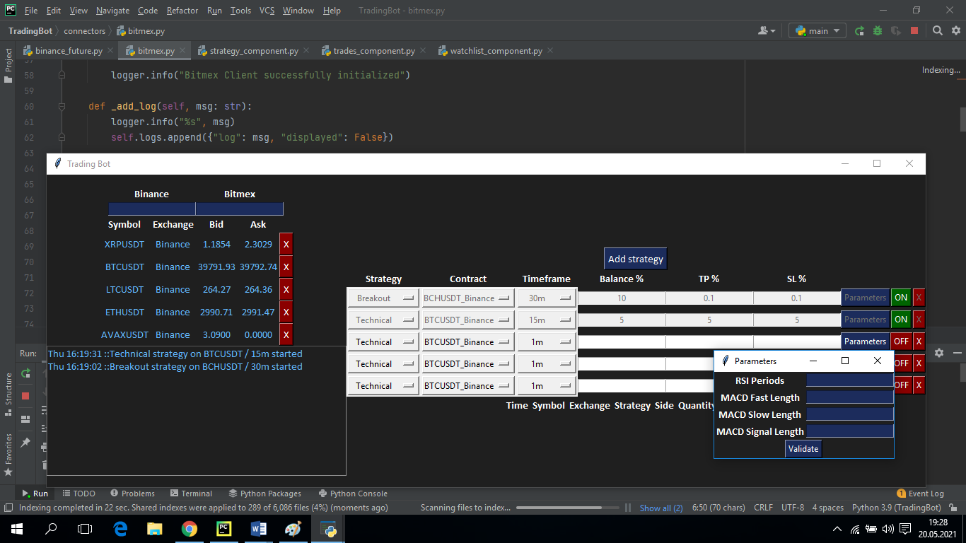

**Figure 8.** Parameter Pop up